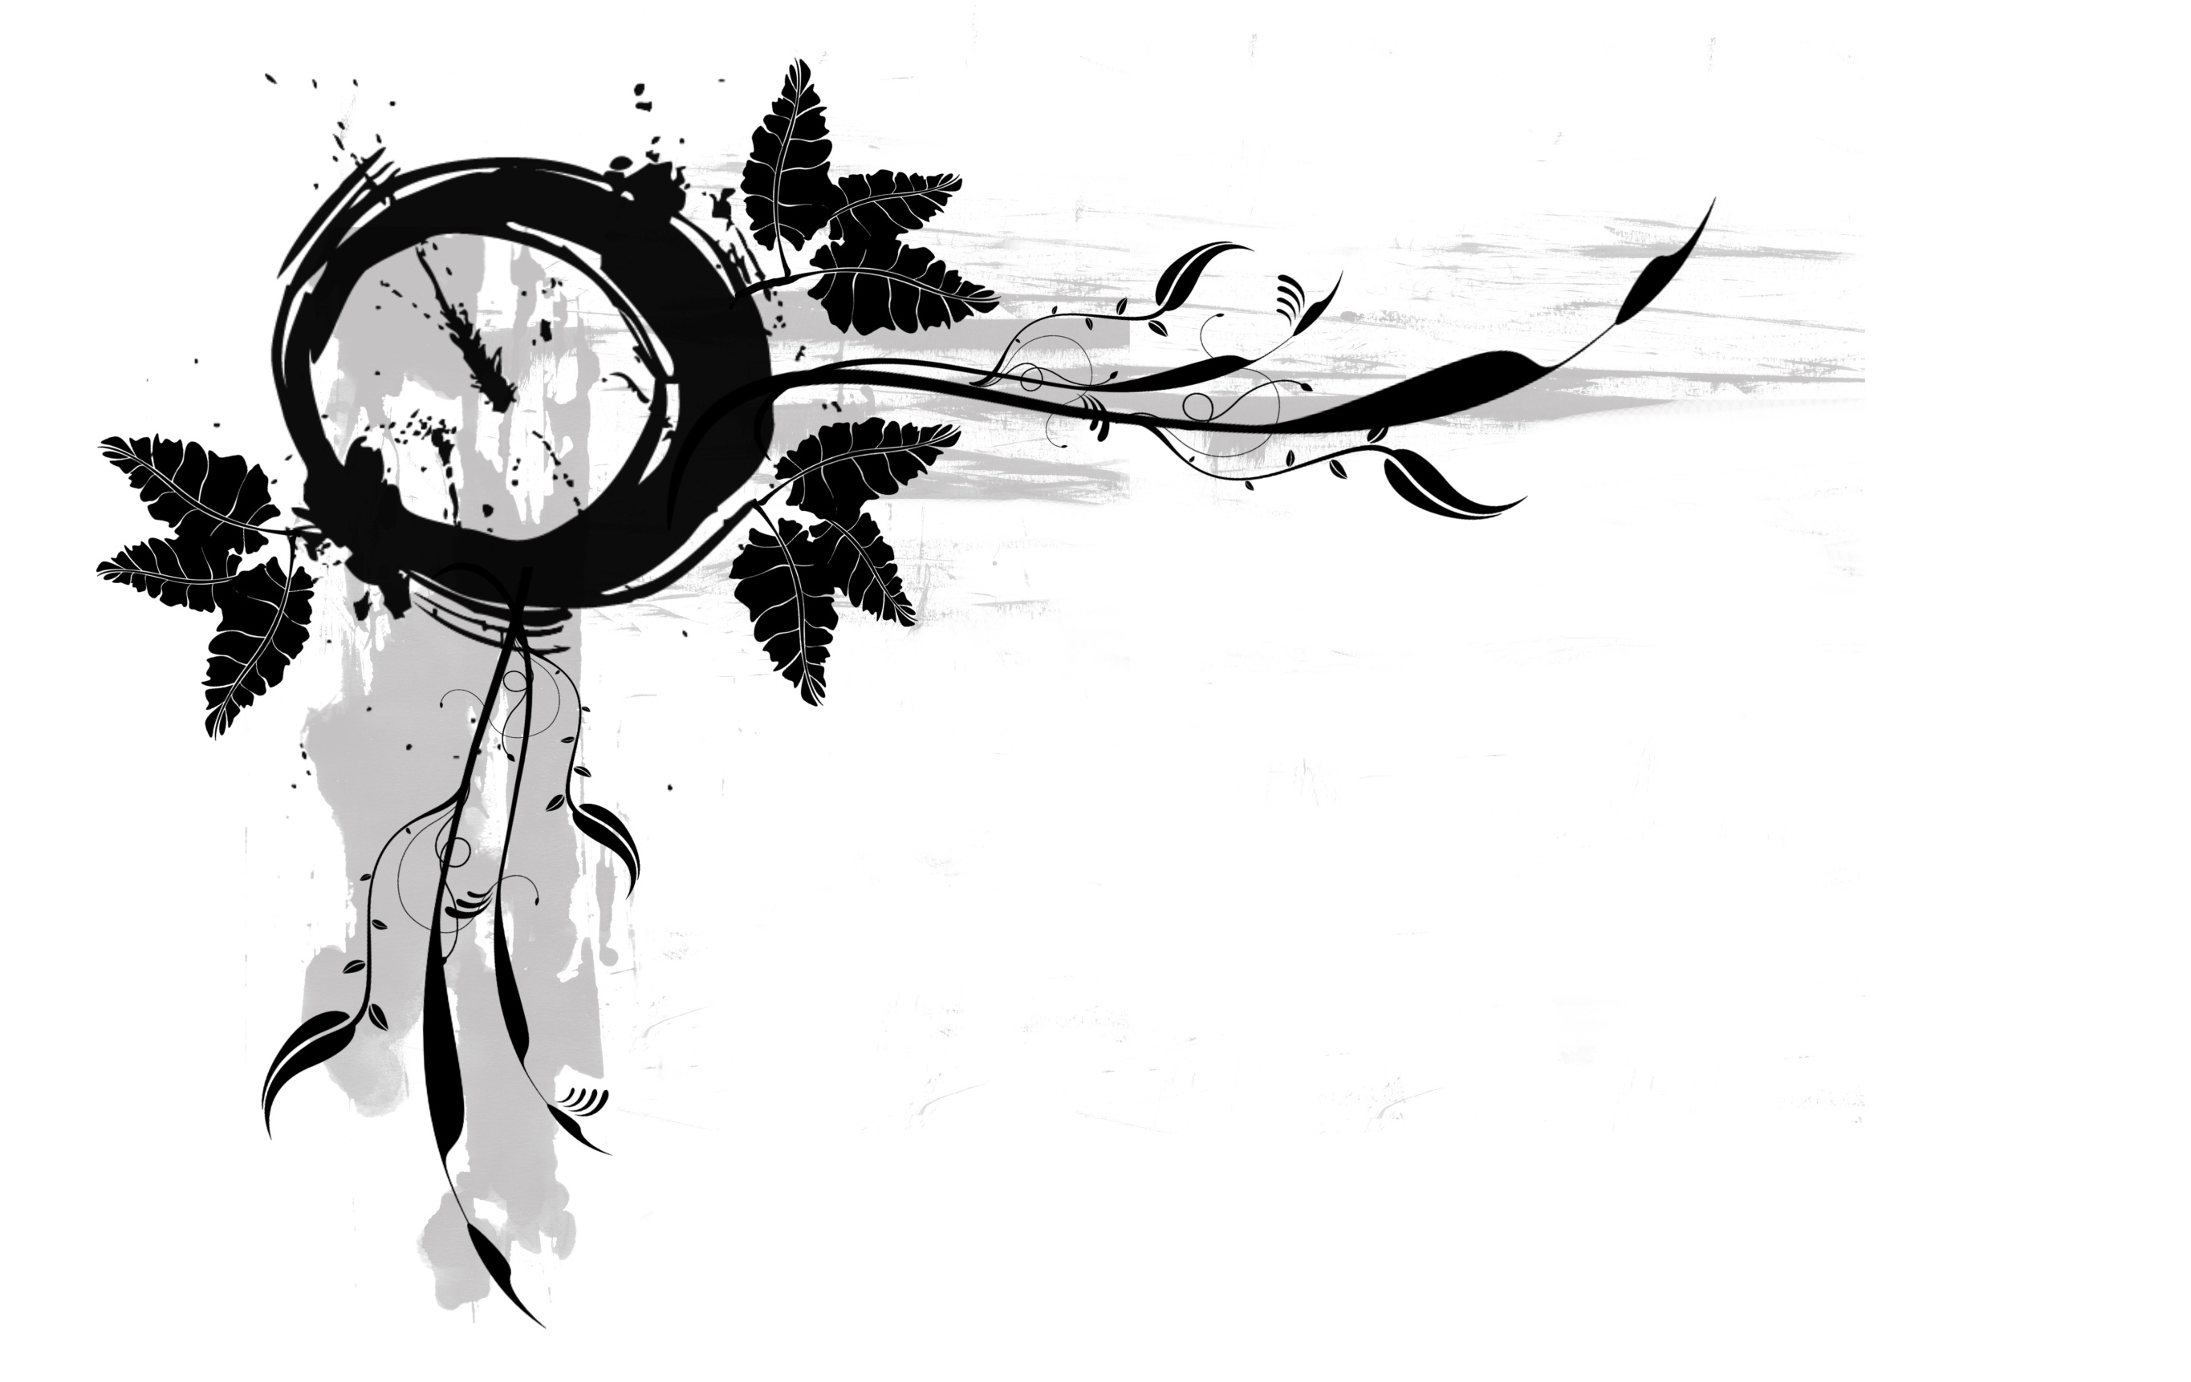
Sun | Mon |  | Tue | Wed |  | Thu | Fri |  | Sat
27 | 28 |  | 29 | 30 |  | 31 | 1 |  | 2
3 | 4 |  | 5 | 6 |  | 7 | 8 |  | 9
10 | 11 |  | 12 | 13 |  | 14 | 15 |  | 16
17 | 18 |  | 19 | 20 |  | 21 | 22 |  | 23
24 | 25 |  | 26 | 27 |  | 28 | 29 |  | 30
31 | 1 |  | 2 | 3  4 |  | 5 | 6
January 2021
Notes:
Jan 01 |  | New Year's Day
Jan 18 |  | M L King Day
Template © calendarlabs.com

February 2021
Notes:
Feb 14 |  | Valentine's Day
Feb 15 |  | Presidents' Day
Sun | Mon |  | Tue | Wed |  | Thu | Fri |  | Sat
31 | 1 |  | 2 | 3 |  | 4 | 5 |  | 6
7 | 8 |  | 9 | 10 |  | 11 | 12 |  | 13
14 | 15 |  | 16 | 17 |  | 18 | 19 |  | 20
21 | 22 |  | 23 | 24 |  | 25 | 26 |  | 27
28 | 1 |  | 2 | 3 |  | 4 | 5 |  | 6
Template © calendarlabs.com
March 2021
Notes:
Sun | Mon |  | Tue | Wed |  | Thu | Fri |  | Sat
28 | 1 |  | 2 | 3 |  | 4 | 5 |  | 6
7 | 8 |  | 9 | 10 |  | 11 | 12 |  | 13
14 | 15 |  | 16 | 17 |  | 18 | 19 |  | 20
21 | 22 |  | 23 | 24 |  | 25 | 26 |  | 27
28 | 29 |  | 30 | 31 |  | 1 | 2 |  | 3
Template © calendarlabs.com
April 2021
Notes:
Apr 02 |  | Good Friday
Apr 04 |  | Easter Sunday
Sun | Mon |  | Tue | Wed |  | Thu | Fri |  | Sat
28 | 29 |  | 30 | 31 |  | 1 | 2 |  | 3
4 | 5 |  | 6 | 7 |  | 8 | 9 |  | 10
11 | 12 |  | 13 | 14 |  | 15 | 16 |  | 17
18 | 19 |  | 20 | 21 |  | 22 | 23 |  | 24
25 | 26 |  | 27 | 28 |  | 29 | 30 |  | 1
Template © calendarlabs.com
Sun | Mon |  | Tue | Wed |  | Thu | Fri |  | Sat
25 | 26 |  | 27 | 28 |  | 29 | 30 |  | 1
2 | 3 |  | 4 | 5 |  | 6 | 7 |  | 8
9 | 10 |  | 11 | 12 |  | 13 | 14 |  | 15
16 | 17 |  | 18 | 19 |  | 20 | 21 |  | 22
23 | 24 |  | 25 | 26 |  | 27 | 28 |  | 29
30 | 31 |  | 1 | 2  3 |  | 4 | 5
May 2021
Notes:
May 09 |  | Mother's Day
May 31 |  | Memorial Day
Template © calendarlabs.com

June 2021
Notes:
Jun 04 |  | National Donut Day
Jun 20 |  | Father's Day
Sun | Mon |  | Tue | Wed |  | Thu | Fri |  | Sat
30 | 31 |  | 1 | 2 |  | 3 | 4 |  | 5
6 | 7 |  | 8 | 9 |  | 10 | 11 |  | 12
13 | 14 |  | 15 | 16 |  | 17 | 18 |  | 19
20 | 21 |  | 22 | 23 |  | 24 | 25 |  | 26
27 | 28 |  | 29 | 30 |  | 1 | 2 |  | 3
Template © calendarlabs.com
July 2021
Notes:
Jul 04 |  | Independence Day
Jul 05 |  | Independence Day Holiday
Sun | Mon |  | Tue | Wed |  | Thu | Fri |  | Sat
27 | 28 |  | 29 | 30 |  | 1 | 2 |  | 3
4 | 5 |  | 6 | 7 |  | 8 | 9 |  | 10
11 | 12 |  | 13 | 14 |  | 15 | 16 |  | 17
18 | 19 |  | 20 | 21 |  | 22 | 23 |  | 24
25 | 26 |  | 27 | 28 |  | 29 | 30 |  | 31
Template © calendarlabs.com
August 2021
Notes:
Sun | Mon |  | Tue | Wed |  | Thu | Fri |  | Sat
1 | 2 |  | 3 | 4 |  | 5 | 6 |  | 7
8 | 9 |  | 10 | 11 |  | 12 | 13 |  | 14
15 | 16 |  | 17 | 18 |  | 19 | 20 |  | 21
22 | 23 |  | 24 | 25 |  | 26 | 27 |  | 28
29 | 30 |  | 31 | 1 |  | 2 | 3 |  | 4
Template © calendarlabs.com
September 2021
Notes:
Sep 06 |  | Labor Day
Sun | Mon |  | Tue | Wed |  | Thu | Fri |  | Sat
29 | 30 |  | 31 | 1 |  | 2 | 3 |  | 4
5 | 6 |  | 7 | 8 |  | 9 | 10 |  | 11
12 | 13 |  | 14 | 15 |  | 16 | 17 |  | 18
19 | 20 |  | 21 | 22 |  | 23 | 24 |  | 25
26 | 27 |  | 28 | 29 |  | 30 | 1 |  | 2
Template © calendarlabs.com
Sun | Mon |  | Tue | Wed |  | Thu | Fri |  | Sat
26 | 27 |  | 28 | 29 |  | 30 | 1 |  | 2
3 | 4 |  | 5 | 6 |  | 7 | 8 |  | 9
10 | 11 |  | 12 | 13 |  | 14 | 15 |  | 16
17 | 18 |  | 19 | 20 |  | 21 | 22 |  | 23
24 | 25 |  | 26 | 27 |  | 28 | 29 |  | 30
31 | 1 |  | 2 | 3  4 |  | 5 | 6
October 2021
Notes:
Oct 11 |  | Columbus Day
Oct 31 |  | Halloween
Template © calendarlabs.com

November 2021
Notes:
Nov 11 |  | Veterans Day
Nov 25 |  | Thanksgiving Day
Sun | Mon |  | Tue | Wed |  | Thu | Fri |  | Sat
31 | 1 |  | 2 | 3 |  | 4 | 5 |  | 6
7 | 8 |  | 9 | 10 |  | 11 | 12 |  | 13
14 | 15 |  | 16 | 17 |  | 18 | 19 |  | 20
21 | 22 |  | 23 | 24 |  | 25 | 26 |  | 27
28 | 29 |  | 30 | 1 |  | 2 | 3 |  | 4
Template © calendarlabs.com
December 2021
Notes:
Dec 25 |  | Christmas
Sun | Mon |  | Tue | Wed |  | Thu | Fri |  | Sat
28 | 29 |  | 30 | 1 |  | 2 | 3 |  | 4
5 | 6 |  | 7 | 8 |  | 9 | 10 |  | 11
12 | 13 |  | 14 | 15 |  | 16 | 17 |  | 18
19 | 20 |  | 21 | 22 |  | 23 | 24 |  | 25
26 | 27 |  | 28 | 29 |  | 30 | 31 |  | 1
Template © calendarlabs.com

