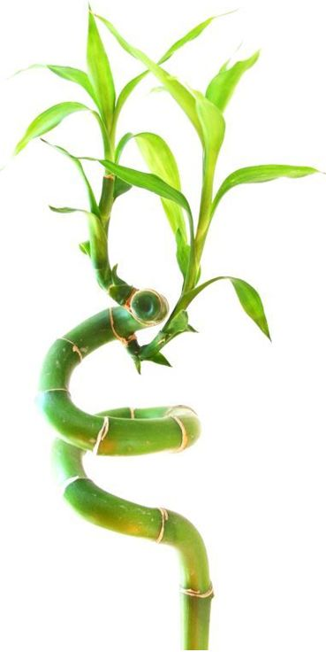 | January 2022
Sun | Mon | Tue | Wed | Thu | Fri | Sat
 |  |  |  |  |  | 1
2 | 3 | 4 | 5 | 6 | 7 | 8
9 | 10 | 11 | 12 | 13 | 14 | 15
16 | 17 | 18 | 19 | 20 | 21 | 22
23 | 24 | 25 | 26 | 27 | 28 | 29
30 | 31

Notes:
Jan 01 | New Year's Day
Jan 17 | M L King Day
 | Template © calendarlabs.com

February 2022
Sun | Mon | Tue | Wed | Thu | Fri | Sat
 |  | 1 | 2 | 3 | 4 | 5
6 | 7 | 8 | 9 | 10 | 11 | 12
13 | 14 | 15 | 16 | 17 | 18 | 19
20 | 21 | 22 | 23 | 24 | 25 | 26
27 | 28

Notes:
Feb 14 | Valentine's Day
Feb 21 | Presidents' Day
 | Template © calendarlabs.com

March 2022
Sun | Mon | Tue | Wed | Thu | Fri | Sat
 |  | 1 | 2 | 3 | 4 | 5
6 | 7 | 8 | 9 | 10 | 11 | 12
13 | 14 | 15 | 16 | 17 | 18 | 19
20 | 21 | 22 | 23 | 24 | 25 | 26
27 | 28 | 29 | 30 | 31

Notes:
Template © calendarlabs.com

April 2022
Sun | Mon | Tue | Wed | Thu | Fri | Sat
 |  |  |  |  | 1 | 2
3 | 4 | 5 | 6 | 7 | 8 | 9
10 | 11 | 12 | 13 | 14 | 15 | 16
17 | 18 | 19 | 20 | 21 | 22 | 23
24 | 25 | 26 | 27 | 28 | 29 | 30

Notes:
Apr 15 | Good Friday
Apr 17 | Easter Sunday
 | Template © calendarlabs.com

May 2022
Sun | Mon | Tue | Wed | Thu | Fri | Sat
1 | 2 | 3 | 4 | 5 | 6 | 7
8 | 9 | 10 | 11 | 12 | 13 | 14
15 | 16 | 17 | 18 | 19 | 20 | 21
22 | 23 | 24 | 25 | 26 | 27 | 28
29 | 30 | 31

Notes:
May 08 | Mother's Day
May 30 | Memorial Day
 | Template © calendarlabs.com

June 2022
Sun | Mon | Tue | Wed | Thu | Fri | Sat
 |  |  | 1 | 2 | 3 | 4
5 | 6 | 7 | 8 | 9 | 10 | 11
12 | 13 | 14 | 15 | 16 | 17 | 18
19 | 20 | 21 | 22 | 23 | 24 | 25
26 | 27 | 28 | 29 | 30

Notes:
Jun 03 | National Donut Day
Jun 19 | Father's Day
 | Template © calendarlabs.com

July 2022
Sun | Mon | Tue | Wed | Thu | Fri | Sat
 |  |  |  |  | 1 | 2
3 | 4 | 5 | 6 | 7 | 8 | 9
10 | 11 | 12 | 13 | 14 | 15 | 16
17 | 18 | 19 | 20 | 21 | 22 | 23
24 | 25 | 26 | 27 | 28 | 29 | 30
31

Notes:
Jul 04 | Independence Day
 | Template © calendarlabs.com

August 2022
Sun | Mon | Tue | Wed | Thu | Fri | Sat
 | 1 | 2 | 3 | 4 | 5 | 6
7 | 8 | 9 | 10 | 11 | 12 | 13
14 | 15 | 16 | 17 | 18 | 19 | 20
21 | 22 | 23 | 24 | 25 | 26 | 27
28 | 29 | 30 | 31

Notes:
Template © calendarlabs.com

September 2022
Sun | Mon | Tue | Wed | Thu | Fri | Sat
 |  |  |  | 1 | 2 | 3
4 | 5 | 6 | 7 | 8 | 9 | 10
11 | 12 | 13 | 14 | 15 | 16 | 17
18 | 19 | 20 | 21 | 22 | 23 | 24
25 | 26 | 27 | 28 | 29 | 30

Notes:
Sep 05 | Labor Day
 | Template © calendarlabs.com

October 2022
Sun | Mon | Tue | Wed | Thu | Fri | Sat
 |  |  |  |  |  | 1
2 | 3 | 4 | 5 | 6 | 7 | 8
9 | 10 | 11 | 12 | 13 | 14 | 15
16 | 17 | 18 | 19 | 20 | 21 | 22
23 | 24 | 25 | 26 | 27 | 28 | 29
30 | 31

Notes:
Oct 10 | Columbus Day
Oct 31 | Halloween
 | Template © calendarlabs.com

November 2022
Sun | Mon | Tue | Wed | Thu | Fri | Sat
 |  | 1 | 2 | 3 | 4 | 5
6 | 7 | 8 | 9 | 10 | 11 | 12
13 | 14 | 15 | 16 | 17 | 18 | 19
20 | 21 | 22 | 23 | 24 | 25 | 26
27 | 28 | 29 | 30

Notes:
Nov 11 | Veterans Day
Nov 24 | Thanksgiving Day
 | Template © calendarlabs.com

December 2022
Sun | Mon | Tue | Wed | Thu | Fri | Sat
 |  |  |  | 1 | 2 | 3
4 | 5 | 6 | 7 | 8 | 9 | 10
11 | 12 | 13 | 14 | 15 | 16 | 17
18 | 19 | 20 | 21 | 22 | 23 | 24
25 | 26 | 27 | 28 | 29 | 30 | 31

Notes:
Dec 25 | Christmas
 | Template © calendarlabs.com

