2022 | 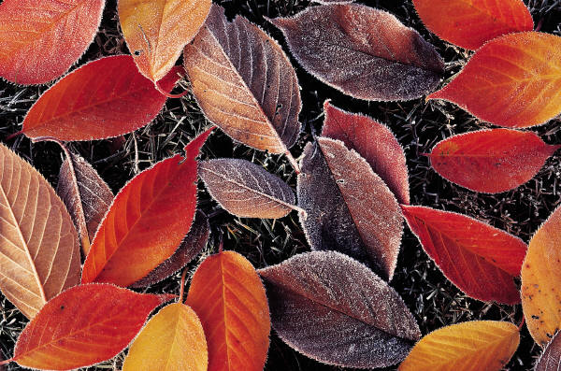 | - IMPORTANT DATES:  - ${t1} ${he1}  - ${t2} ${he2}  - ${t3} ${he3}  - ${t4} ${he4}  - ${t5} ${he5}  - ${t6} ${he6}  - ${t7} ${he7}  - ${t8} ${he8}  - ${t9} ${he9}

January 2022  S M T W T F S  1  2 3 4 5 6 7 8  9 10 11 12 13 14 15  16 17 18 19 20 21 22  23 24 25 26 27 28 29  30 31 |  |  | February 2022  S M T W T F S  1 2 3 4 5  6 7 8 9 10 11 12  13 14 15 16 17 18 19  20 21 22 23 24 25 26  27 28 |  |  | March 2022  S M T W T F S  1 2 3 4 5  6 7 8 9 10 11 12  13 14 15 16 17 18 19  20 21 22 23 24 25 26  27 28 29 30 31

2022 |  | - IMPORTANT DATES:  - ${t1} ${he1}  - ${t2} ${he2}  - ${t3} ${he3}  - ${t4} ${he4}  - ${t5} ${he5}  - ${t6} ${he6}  - ${t7} ${he7}  - ${t8} ${he8}  - ${t9} ${he9}

April 2022  S M T W T F S  1 2  3 4 5 6 7 8 9  10 11 12 13 14 15 16  17 18 19 20 21 22 23  24 25 26 27 28 29 30 |  |  | May 2022  S M T W T F S  1 2 3 4 5 6 7  8 9 10 11 12 13 14  15 16 17 18 19 20 21  22 23 24 25 26 27 28  29 30 31 |  |  | June 2022  S M T W T F S  1 2 3 4  5 6 7 8 9 10 11  12 13 14 15 16 17 18  19 20 21 22 23 24 25  26 27 28 29 30

2022 |  | - IMPORTANT DATES:  - ${t1} ${he1}  - ${t2} ${he2}  - ${t3} ${he3}  - ${t4} ${he4}  - ${t5} ${he5}  - ${t6} ${he6}  - ${t7} ${he7}  - ${t8} ${he8}  - ${t9} ${he9}

July 2022  S M T W T F S  1 2  3 4 5 6 7 8 9  10 11 12 13 14 15 16  17 18 19 20 21 22 23  24 25 26 27 28 29 30  31 |  |  | August 2022  S M T W T F S  1 2 3 4 5 6  7 8 9 10 11 12 13  14 15 16 17 18 19 20  21 22 23 24 25 26 27  28 29 30 31 |  |  | September 2022  S M T W T F S  1 2 3  4 5 6 7 8 9 10  11 12 13 14 15 16 17  18 19 20 21 22 23 24  25 26 27 28 29 30

2022 |  | - IMPORTANT DATES:  - ${t1} ${he1}  - ${t2} ${he2}  - ${t3} ${he3}  - ${t4} ${he4}  - ${t5} ${he5}  - ${t6} ${he6}  - ${t7} ${he7}  - ${t8} ${he8}  - ${t9} ${he9}

October 2022  S M T W T F S  1  2 3 4 5 6 7 8  9 10 11 12 13 14 15  16 17 18 19 20 21 22  23 24 25 26 27 28 29  30 31 |  |  | November 2022  S M T W T F S  1 2 3 4 5  6 7 8 9 10 11 12  13 14 15 16 17 18 19  20 21 22 23 24 25 26  27 28 29 30 |  |  | December 2022  S M T W T F S  1 2 3  4 5 6 7 8 9 10  11 12 13 14 15 16 17  18 19 20 21 22 23 24  25 26 27 28 29 30 31

