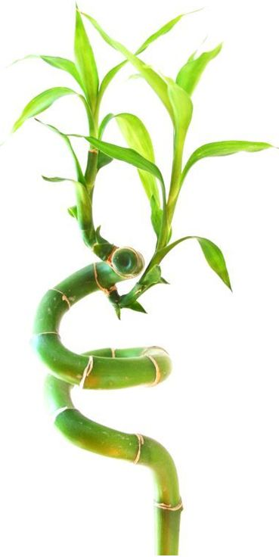 | January 2025
SUN | MON | TUE | WED | THU | FRI | SAT
 |  |  | 1 | 2 | 3 | 4
5 | 6 | 7 | 8 | 9 | 10 | 11
12 | 13 | 14 | 15 | 16 | 17 | 18
19 | 20 | 21 | 22 | 23 | 24 | 25
26 | 27 | 28 | 29 | 30 | 31

Notes:
Jan 01 | New Year's Day
Jan 20 | M L King Day
 | Template © calendarlabs.com

February 2025
SUN | MON | TUE | WED | THU | FRI | SAT
 |  |  |  |  |  | 1
2 | 3 | 4 | 5 | 6 | 7 | 8
9 | 10 | 11 | 12 | 13 | 14 | 15
16 | 17 | 18 | 19 | 20 | 21 | 22
23 | 24 | 25 | 26 | 27 | 28

Notes:
Feb 17 | Presidents' Day
 | Template © calendarlabs.com

March 2025
SUN | MON | TUE | WED | THU | FRI | SAT
 |  |  |  |  |  | 1
2 | 3 | 4 | 5 | 6 | 7 | 8
9 | 10 | 11 | 12 | 13 | 14 | 15
16 | 17 | 18 | 19 | 20 | 21 | 22
23 | 24 | 25 | 26 | 27 | 28 | 29
30 | 31

Notes:
Template © calendarlabs.com

April 2025
SUN | MON | TUE | WED | THU | FRI | SAT
 |  | 1 | 2 | 3 | 4 | 5
6 | 7 | 8 | 9 | 10 | 11 | 12
13 | 14 | 15 | 16 | 17 | 18 | 19
20 | 21 | 22 | 23 | 24 | 25 | 26
27 | 28 | 29 | 30

Notes:
Apr 18 | Good Friday
Apr 20 | Easter Sunday
 | Template © calendarlabs.com

May 2025
SUN | MON | TUE | WED | THU | FRI | SAT
 |  |  |  | 1 | 2 | 3
4 | 5 | 6 | 7 | 8 | 9 | 10
11 | 12 | 13 | 14 | 15 | 16 | 17
18 | 19 | 20 | 21 | 22 | 23 | 24
25 | 26 | 27 | 28 | 29 | 30 | 31

Notes:
May 26 | Memorial Day
 | Template © calendarlabs.com

June 2025
SUN | MON | TUE | WED | THU | FRI | SAT
1 | 2 | 3 | 4 | 5 | 6 | 7
8 | 9 | 10 | 11 | 12 | 13 | 14
15 | 16 | 17 | 18 | 19 | 20 | 21
22 | 23 | 24 | 25 | 26 | 27 | 28
29 | 30

Notes:
Jun 19 | Juneteenth
 | Template © calendarlabs.com

July 2025
SUN | MON | TUE | WED | THU | FRI | SAT
 |  | 1 | 2 | 3 | 4 | 5
6 | 7 | 8 | 9 | 10 | 11 | 12
13 | 14 | 15 | 16 | 17 | 18 | 19
20 | 21 | 22 | 23 | 24 | 25 | 26
27 | 28 | 29 | 30 | 31

Notes:
Jul 04 | Independence Day
 | Template © calendarlabs.com

August 2025
SUN | MON | TUE | WED | THU | FRI | SAT
 |  |  |  |  | 1 | 2
3 | 4 | 5 | 6 | 7 | 8 | 9
10 | 11 | 12 | 13 | 14 | 15 | 16
17 | 18 | 19 | 20 | 21 | 22 | 23
24 | 25 | 26 | 27 | 28 | 29 | 30
31

Notes:
Template © calendarlabs.com

September 2025
SUN | MON | TUE | WED | THU | FRI | SAT
 | 1 | 2 | 3 | 4 | 5 | 6
7 | 8 | 9 | 10 | 11 | 12 | 13
14 | 15 | 16 | 17 | 18 | 19 | 20
21 | 22 | 23 | 24 | 25 | 26 | 27
28 | 29 | 30

Notes:
Sep 01 | Labor Day
 | Template © calendarlabs.com

October 2025
SUN | MON | TUE | WED | THU | FRI | SAT
 |  |  | 1 | 2 | 3 | 4
5 | 6 | 7 | 8 | 9 | 10 | 11
12 | 13 | 14 | 15 | 16 | 17 | 18
19 | 20 | 21 | 22 | 23 | 24 | 25
26 | 27 | 28 | 29 | 30 | 31

Notes:
Oct 13 | Columbus Day
 | Template © calendarlabs.com

November 2025
SUN | MON | TUE | WED | THU | FRI | SAT
 |  |  |  |  |  | 1
2 | 3 | 4 | 5 | 6 | 7 | 8
9 | 10 | 11 | 12 | 13 | 14 | 15
16 | 17 | 18 | 19 | 20 | 21 | 22
23 | 24 | 25 | 26 | 27 | 28 | 29
30

Notes:
Nov 11 | Veterans Day
Nov 27 | Thanksgiving Day
 | Template © calendarlabs.com

December 2025
SUN | MON | TUE | WED | THU | FRI | SAT
 | 1 | 2 | 3 | 4 | 5 | 6
7 | 8 | 9 | 10 | 11 | 12 | 13
14 | 15 | 16 | 17 | 18 | 19 | 20
21 | 22 | 23 | 24 | 25 | 26 | 27
28 | 29 | 30 | 31

Notes:
Dec 25 | Christmas
 | Template © calendarlabs.com

