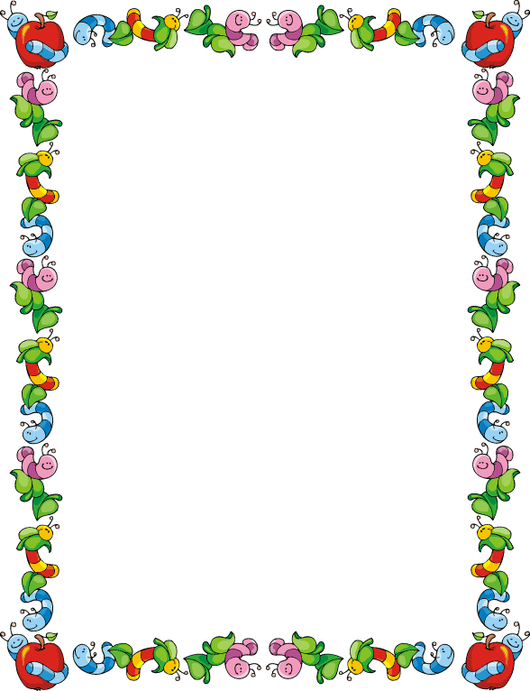
January 2026
Sunday | Monday | Tuesday | Wednesday |  | Thursday | Friday | Saturday
 |  |  |  |  | 1 | 2 | 3
4 | 5 | 6 | 7 |  | 8 | 9 | 10
11 | 12 | 13 | 14 |  | 15 | 16 | 17
18 | 19 | 20 | 21 |  | 22 | 23 | 24
25 | 26 | 27 | 28 |  | 29 | 30 | 31
Notes:
Jan 01 : New Year’s Day
Jan 19 : M L King Day
Template © calendarlabs.com

February 2026
Sunday | Monday | Tuesday | Wednesday |  | Thursday | Friday | Saturday
1 | 2 | 3 | 4 |  | 5 | 6 | 7
8 | 9 | 10 | 11 |  | 12 | 13 | 14
15 | 16 | 17 | 18 |  | 19 | 20 | 21
22 | 23 | 24 | 25 |  | 26 | 27 | 28
Notes:
Feb 16 : Presidents’ Day
Template © calendarlabs.com

March 2026
Sunday | Monday | Tuesday | Wednesday |  | Thursday | Friday | Saturday
1 | 2 | 3 | 4 |  | 5 | 6 | 7
8 | 9 | 10 | 11 |  | 12 | 13 | 14
15 | 16 | 17 | 18 |  | 19 | 20 | 21
22 | 23 | 24 | 25 |  | 26 | 27 | 28
29 | 30 | 31
Notes:
Template © calendarlabs.com

April 2026
Sunday | Monday | Tuesday | Wednesday |  | Thursday | Friday | Saturday
 |  |  | 1 |  | 2 | 3 | 4
5 | 6 | 7 | 8 |  | 9 | 10 | 11
12 | 13 | 14 | 15 |  | 16 | 17 | 18
19 | 20 | 21 | 22 |  | 23 | 24 | 25
26 | 27 | 28 | 29 |  | 30
Notes:
Apr 03: Good Friday
Apr 05: Easter Sunday
Template © calendarlabs.com

May 2026
Sunday | Monday | Tuesday | Wednesday |  | Thursday | Friday | Saturday
 |  |  |  |  |  | 1 | 2
3 | 4 | 5 | 6 |  | 7 | 8 | 9
10 | 11 | 12 | 13 |  | 14 | 15 | 16
17 | 18 | 19 | 20 |  | 21 | 22 | 23
24 | 25 | 26 | 27 |  | 28 | 29 | 30
31
Notes:
May 25 : Memorial Day
Template © calendarlabs.com

June 2026
Sunday | Monday | Tuesday | Wednesday |  | Thursday | Friday | Saturday
 | 1 | 2 | 3 |  | 4 | 5 | 6
7 | 8 | 9 | 10 |  | 11 | 12 | 13
14 | 15 | 16 | 17 |  | 18 | 19 | 20
21 | 22 | 23 | 24 |  | 25 | 26 | 27
28 | 29 | 30
Notes:
Jun 19: Juneteenth
Template © calendarlabs.com

July 2026
Sunday | Monday | Tuesday | Wednesday |  | Thursday | Friday | Saturday
 |  |  | 1 |  | 2 | 3 | 4
5 | 6 | 7 | 8 |  | 9 | 10 | 11
12 | 13 | 14 | 15 |  | 16 | 17 | 18
19 | 20 | 21 | 22 |  | 23 | 24 | 25
26 | 27 | 28 | 29 |  | 30 | 31
Notes:
Jul 03 : Independence Day Holiday
Jul 04 : Independence Day
Template © calendarlabs.com

August 2026
Sunday | Monday | Tuesday | Wednesday |  | Thursday | Friday | Saturday
 |  |  |  |  |  |  | 1
2 | 3 | 4 | 5 |  | 6 | 7 | 8
9 | 10 | 11 | 12 |  | 13 | 14 | 15
16 | 17 | 18 | 19 |  | 20 | 21 | 22
23 | 24 | 25 | 26 |  | 27 | 28 | 29
30 | 31
Notes:
Template © calendarlabs.com

September 2026
Sunday | Monday | Tuesday | Wednesday |  | Thursday | Friday | Saturday
 |  | 1 | 2 |  | 3 | 4 | 5
6 | 7 | 8 | 9 |  | 10 | 11 | 12
13 | 14 | 15 | 16 |  | 17 | 18 | 19
20 | 21 | 22 | 23 |  | 24 | 25 | 26
27 | 28 | 29 | 30
Notes:
Sep 07 : Labor Day
Template © calendarlabs.com

October 2026
Sunday | Monday | Tuesday | Wednesday |  | Thursday | Friday | Saturday
 |  |  |  |  | 1 | 2 | 3
4 | 5 | 6 | 7 |  | 8 | 9 | 10
11 | 12 | 13 | 14 |  | 15 | 16 | 17
18 | 19 | 20 | 21 |  | 22 | 23 | 24
25 | 26 | 27 | 28 |  | 29 | 30 | 31
Notes:
Oct 12 : Columbus Day
Template © calendarlabs.com

November 2026
Sunday | Monday | Tuesday | Wednesday |  | Thursday | Friday | Saturday
1 | 2 | 3 | 4 |  | 5 | 6 | 7
8 | 9 | 10 | 11 |  | 12 | 13 | 14
15 | 16 | 17 | 18 |  | 19 | 20 | 21
22 | 23 | 24 | 25 |  | 26 | 27 | 28
29 | 30
Notes:
Nov 11 : Veterans Day
Nov 26 : Thanksgiving Day
Template © calendarlabs.com

December 2026
Sunday | Monday | Tuesday | Wednesday |  | Thursday | Friday | Saturday
 |  | 1 | 2 |  | 3 | 4 | 5
6 | 7 | 8 | 9 |  | 10 | 11 | 12
13 | 14 | 15 | 16 |  | 17 | 18 | 19
20 | 21 | 22 | 23 |  | 24 | 25 | 26
27 | 28 | 29 | 30 |  | 31
Notes:
Dec 25 : Christmas
Template © calendarlabs.com

