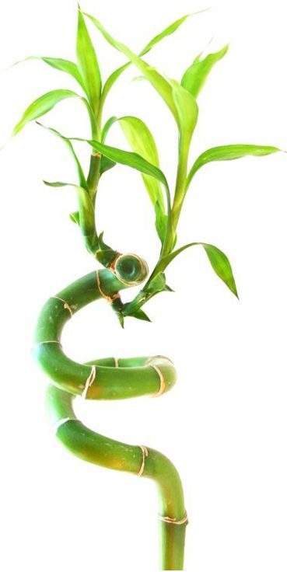 | Enero 2026
Dom | Lun | Mar | Mie | Jue | Vie | Sab
 |  |  |  | 1 | 2 | 3
4 | 5 | 6 | 7 | 8 | 9 | 10
11 | 12 | 13 | 14 | 15 | 16 | 17
18 | 19 | 20 | 21 | 22 | 23 | 24
25 | 26 | 27 | 28 | 29 | 30 | 31

Notes:
Jan 01 | Día de año nuevo
Jan 19 | Día de m l king
 | 

Febrero 2026
Dom | Lun | Mar | Mie | Jue | Vie | Sab
1 | 2 | 3 | 4 | 5 | 6 | 7
8 | 9 | 10 | 11 | 12 | 13 | 14
15 | 16 | 17 | 18 | 19 | 20 | 21
22 | 23 | 24 | 25 | 26 | 27 | 28

Notes:
Feb 16 | Día del presidente

Marzo 2026
Dom | Lun | Mar | Mie | Jue | Vie | Sab
1 | 2 | 3 | 4 | 5 | 6 | 7
8 | 9 | 10 | 11 | 12 | 13 | 14
15 | 16 | 17 | 18 | 19 | 20 | 21
22 | 23 | 24 | 25 | 26 | 27 | 28
29 | 30 | 31

Notes:

Abril 2026
Dom | Lun | Mar | Mie | Jue | Vie | Sab
 |  |  | 1 | 2 | 3 | 4
5 | 6 | 7 | 8 | 9 | 10 | 11
12 | 13 | 14 | 15 | 16 | 17 | 18
19 | 20 | 21 | 22 | 23 | 24 | 25
26 | 27 | 28 | 29 | 30

Notes:
Apr 03 | Buen viernes
Apr 05 | Domingo de pascua

Mayo 2026
Dom | Lun | Mar | Mie | Jue | Vie | Sab
 |  |  |  |  | 1 | 2
3 | 4 | 5 | 6 | 7 | 8 | 9
10 | 11 | 12 | 13 | 14 | 15 | 16
17 | 18 | 19 | 20 | 21 | 22 | 23
24 | 25 | 26 | 27 | 28 | 29 | 30
31

Notes:
May 25 | Día conmemorativo

Junio 2026
Dom | Lun | Mar | Mie | Jue | Vie | Sab
 | 1 | 2 | 3 | 4 | 5 | 6
7 | 8 | 9 | 10 | 11 | 12 | 13
14 | 15 | 16 | 17 | 18 | 19 | 20
21 | 22 | 23 | 24 | 25 | 26 | 27
28 | 29 | 30

Notes:
Jun 19 | Juneteenth

Julio 2026
Dom | Lun | Mar | Mie | Jue | Vie | Sab
 |  |  | 1 | 2 | 3 | 4
5 | 6 | 7 | 8 | 9 | 10 | 11
12 | 13 | 14 | 15 | 16 | 17 | 18
19 | 20 | 21 | 22 | 23 | 24 | 25
26 | 27 | 28 | 29 | 30 | 31

Notes:
Jul 03 | Día de la independencia
Jul 04 | Día de la independencia

Agosto 2026
Dom | Lun | Mar | Mie | Jue | Vie | Sab
 |  |  |  |  |  | 1
2 | 3 | 4 | 5 | 6 | 7 | 8
9 | 10 | 11 | 12 | 13 | 14 | 15
16 | 17 | 18 | 19 | 20 | 21 | 22
23 | 24 | 25 | 26 | 27 | 28 | 29
30 | 31

Notes:

Septiembre 2026
Dom | Lun | Mar | Mie | Jue | Vie | Sab
 |  | 1 | 2 | 3 | 4 | 5
6 | 7 | 8 | 9 | 10 | 11 | 12
13 | 14 | 15 | 16 | 17 | 18 | 19
20 | 21 | 22 | 23 | 24 | 25 | 26
27 | 28 | 29 | 30

Notes:
Sep 07 | Día laboral

Octubre 2026
Dom | Lun | Mar | Mie | Jue | Vie | Sab
 |  |  |  | 1 | 2 | 3
4 | 5 | 6 | 7 | 8 | 9 | 10
11 | 12 | 13 | 14 | 15 | 16 | 17
18 | 19 | 20 | 21 | 22 | 23 | 24
25 | 26 | 27 | 28 | 29 | 30 | 31

Notes:
Oct 12 | Día de la raza

Noviembre 2026
Dom | Lun | Mar | Mie | Jue | Vie | Sab
1 | 2 | 3 | 4 | 5 | 6 | 7
8 | 9 | 10 | 11 | 12 | 13 | 14
15 | 16 | 17 | 18 | 19 | 20 | 21
22 | 23 | 24 | 25 | 26 | 27 | 28
29 | 30

Notes:
Nov 11 | Día de los veteranos
Nov 26 | Día de gracias

Diciembre 2026
Dom | Lun | Mar | Mie | Jue | Vie | Sab
 |  | 1 | 2 | 3 | 4 | 5
6 | 7 | 8 | 9 | 10 | 11 | 12
13 | 14 | 15 | 16 | 17 | 18 | 19
20 | 21 | 22 | 23 | 24 | 25 | 26
27 | 28 | 29 | 30 | 31

Notes:
Dec 25 | Navidad

