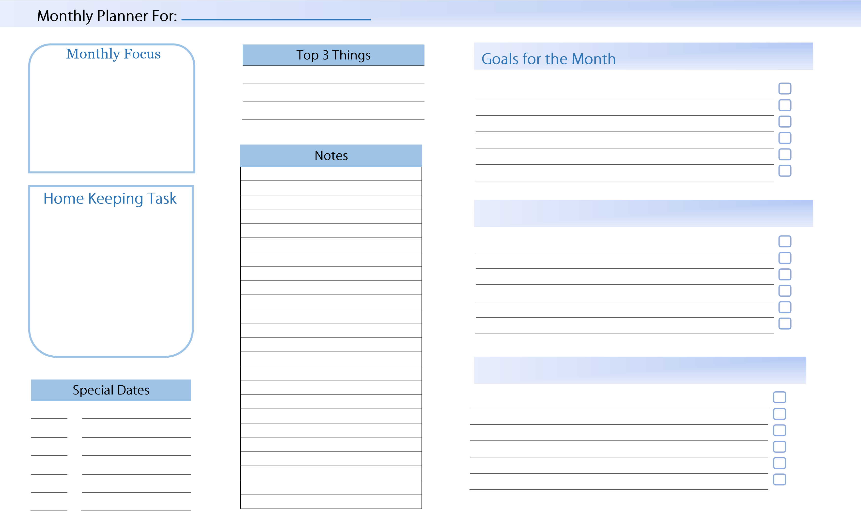
Monthly Planner © CalendarLabs.com

