2027
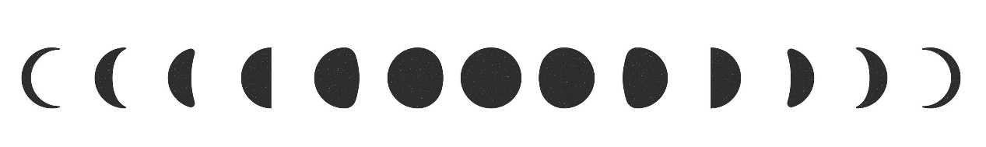
Lunar Calendar
January |  |  |  |  |  | February |  |  |  |  |  |  |  |  |  | March
 |  |  | 
7 | 15 | 22 | 29 |  |  |  | 6 | 14 |  | 20 | 28 |  |  |  |  | 8 |  | 15 | 22 | 30
April |  |  |  |  |  | May |  |  |  |  |  |  |  |  |  | June
6 | 13 | 20 | 28 |  |  |  | 6 | 13 |  | 20 | 28 |  |  |  |  | 4 |  | 11 | 19 | 27
July |  |  |  |  |  | August |  |  |  |  |  |  |  |  |  | September
4 | 10 | 18 | 26 |  |  | 2 | 9 | 17 |  | 25 | 31 |  |  |  |  | 7 |  | 15 | 23 | 30
October |  |  |  |  |  | November |  |  |  |  |  |  |  |  |  | December
7 | 15 | 22 | 29 |  |  |  | 6 | 14 |  | 21 | 28 |  |  |  |  | 6 |  | 13 | 20 | 27
Full Moon |  |  |  |  | First Quarter |  |  |  |  | New Moon |  |  |  |  |  |  | Last Quarter
Lunar & Solar Eclipse
Mar 03 (11:35) - Total Lunar Eclipse |  |  |  |  |  |  |  |  | Feb 06 (16:00) - Annual Solar Eclipse
Feb 20 (23:13) - Penumbral lunar eclipse |  |  |  |  |  |  |  |  | Aug 17 (07:14) - Penumbral lunar eclipse

