January

 | S | M | T | W | T | F | S
 |  |  |  |  |  | 1 | 2
 | 3 | 4 | 5 | 6 | 7 | 8 | 9
 | 10 | 11 | 12 | 13 | 14 | 15 | 16
 | 17 | 18 | 19 | 20 | 21 | 22 | 23
 | 24 | 25 | 26 | 27 | 28 | 29 | 30
 | 31
 | Notes:
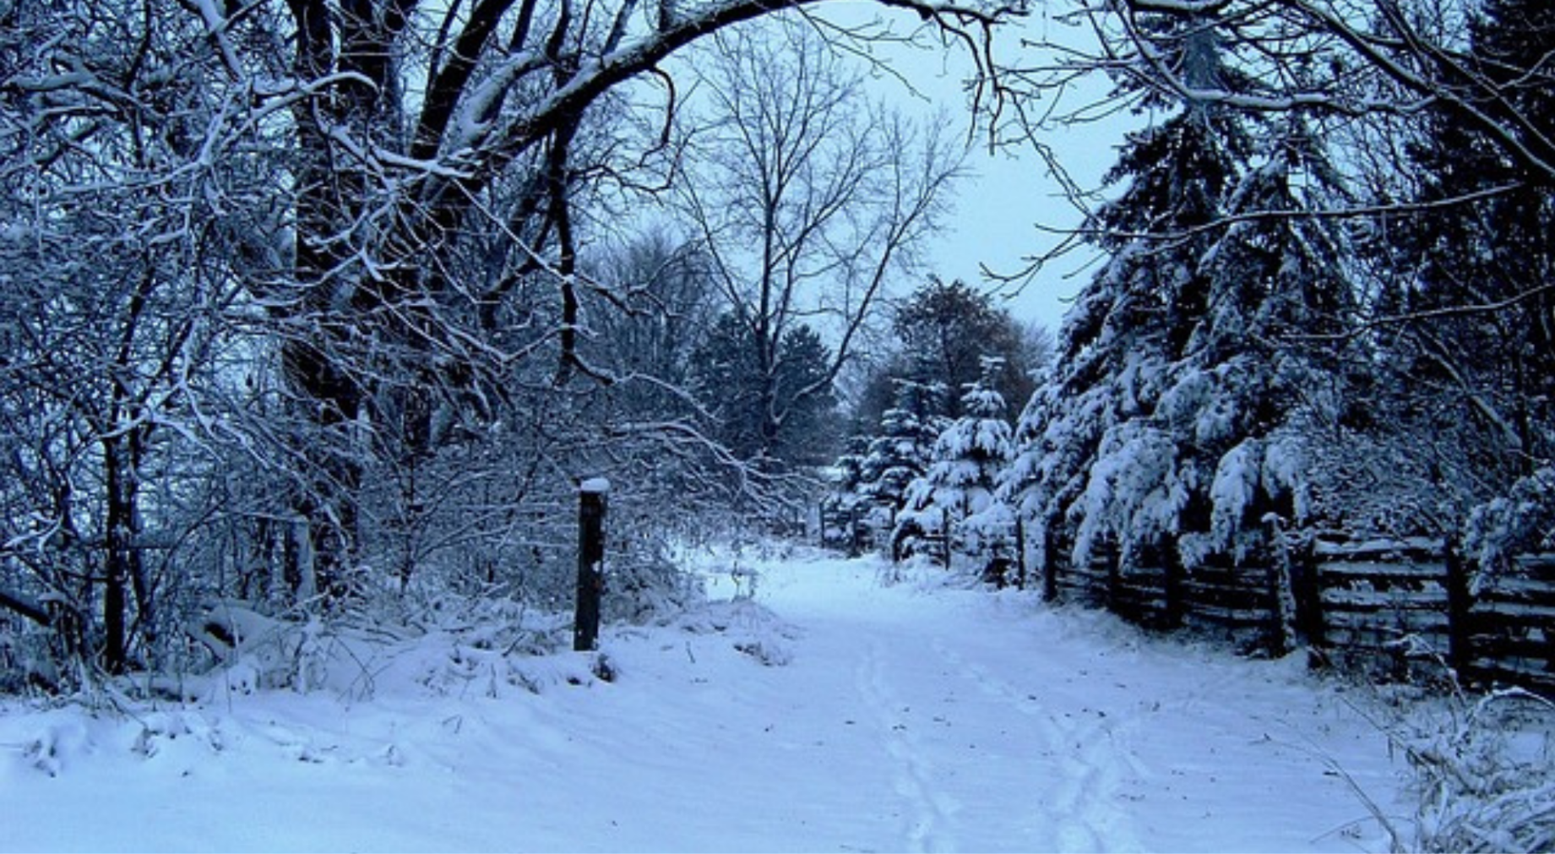
February
 | S | M | T | W | T | F | S
 |  | 1 | 2 | 3 | 4 | 5 | 6
 | 7 | 8 | 9 | 10 | 11 | 12 | 13
 | 14 | 15 | 16 | 17 | 18 | 19 | 20
 | 21 | 22 | 23 | 24 | 25 | 26 | 27
 | 28
 | Notes:
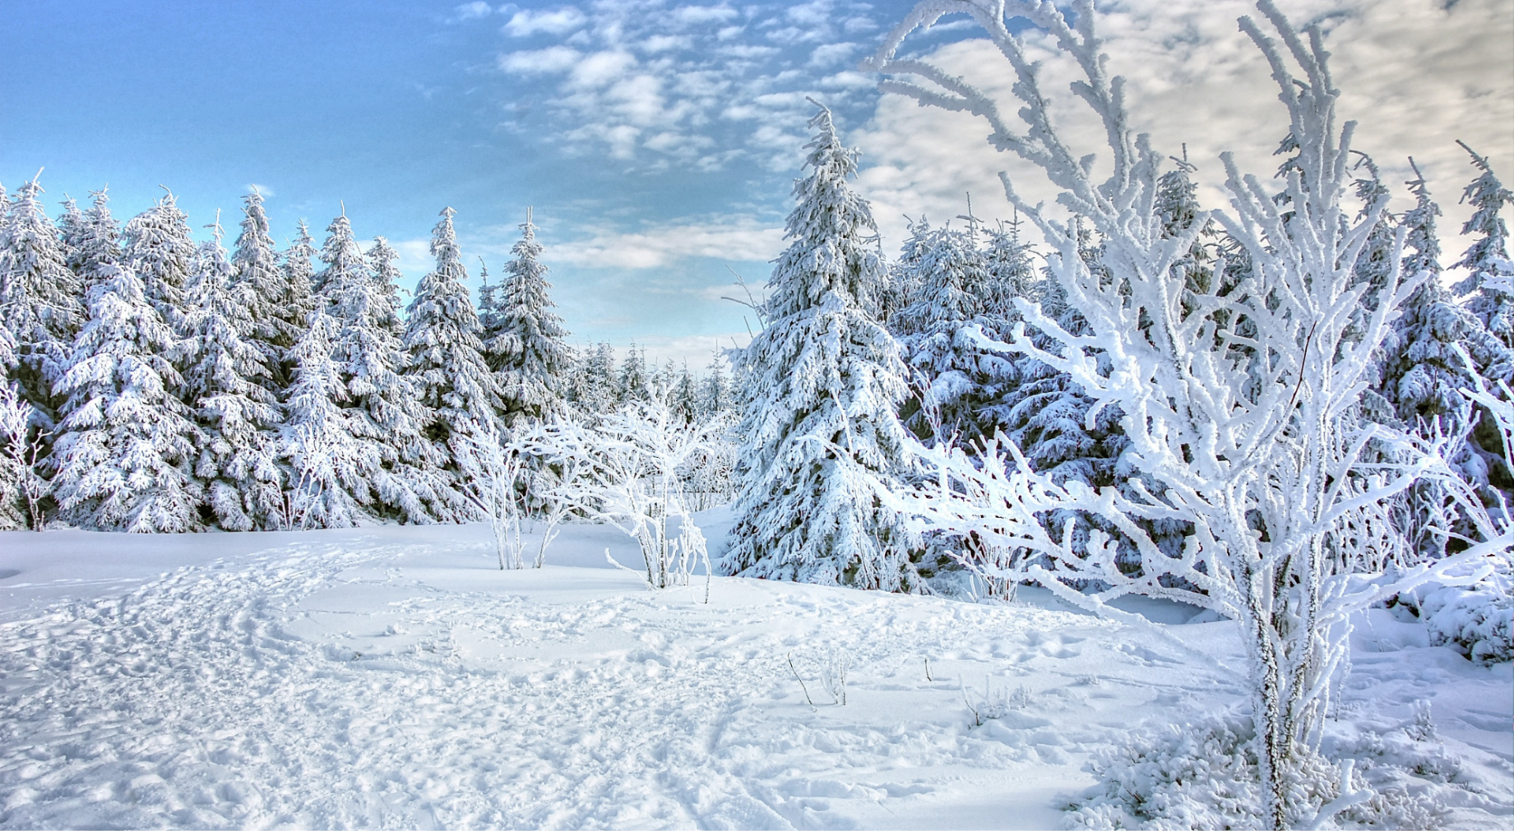
March
 | S | M | T | W | T | F | S
 |  | 1 | 2 | 3 | 4 | 5 | 6
 | 7 | 8 | 9 | 10 | 11 | 12 | 13
 | 14 | 15 | 16 | 17 | 18 | 19 | 20
 | 21 | 22 | 23 | 24 | 25 | 26 | 27
 | 28 | 29 | 30 | 31
 | Notes:
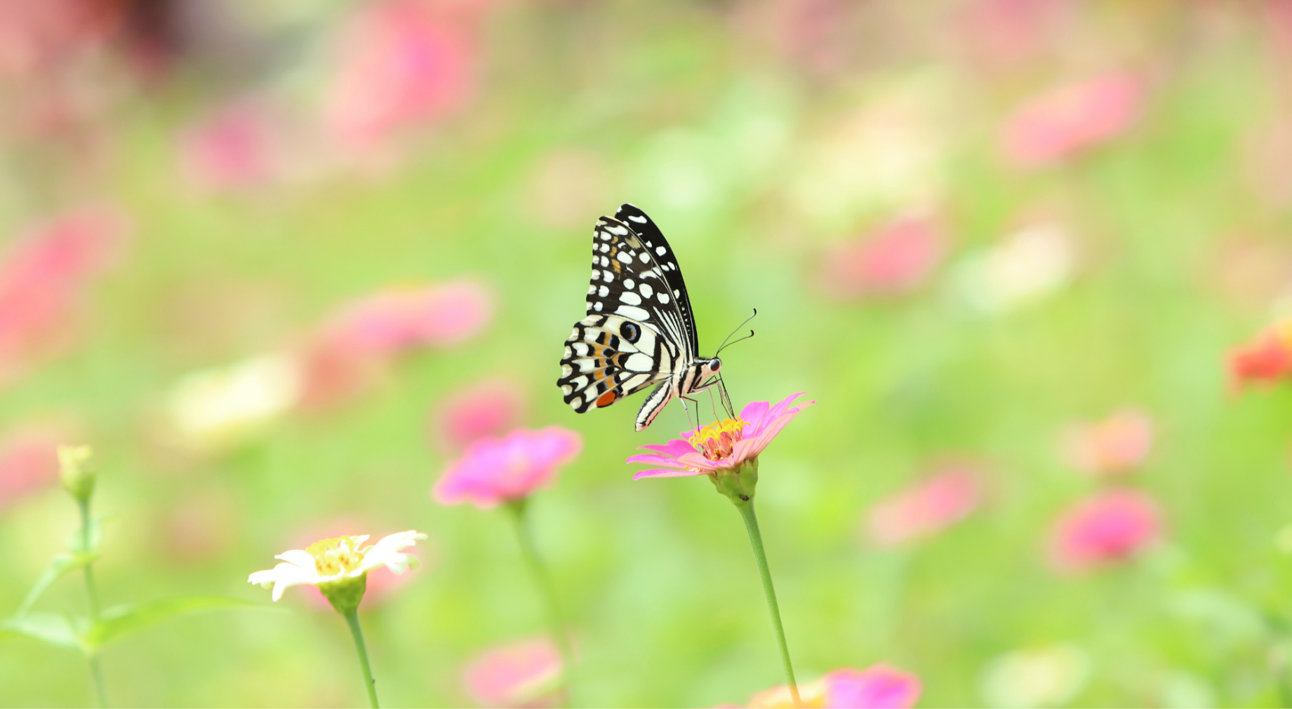
April
 | S | M | T | W | T | F | S
 |  |  |  |  | 1 | 2 | 3
 | 4 | 5 | 6 | 7 | 8 | 9 | 10
 | 11 | 12 | 13 | 14 | 15 | 16 | 17
 | 18 | 19 | 20 | 21 | 22 | 23 | 24
 | 25 | 26 | 27 | 28 | 29 | 30
 | Notes:
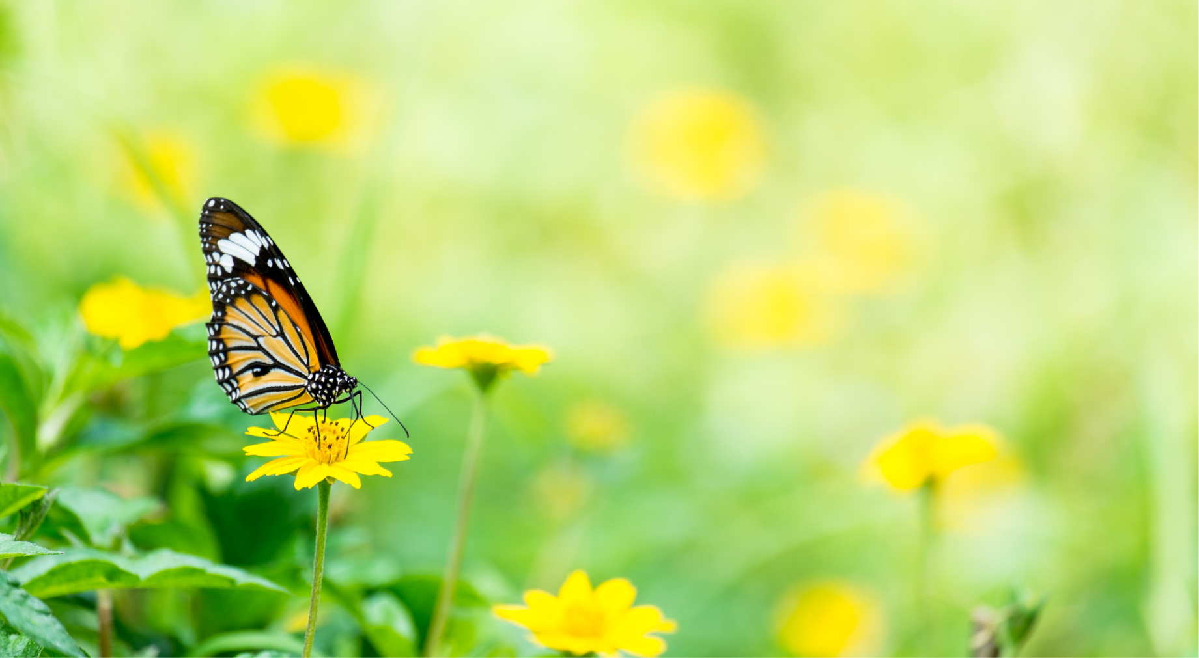
May
 | S | M | T | W | T | F | S
 |  |  |  |  |  |  | 1
 | 2 | 3 | 4 | 5 | 6 | 7 | 8
 | 9 | 10 | 11 | 12 | 13 | 14 | 15
 | 16 | 17 | 18 | 19 | 20 | 21 | 22
 | 23 | 24 | 25 | 26 | 27 | 28 | 29
 | 30 | 31
 | Notes:
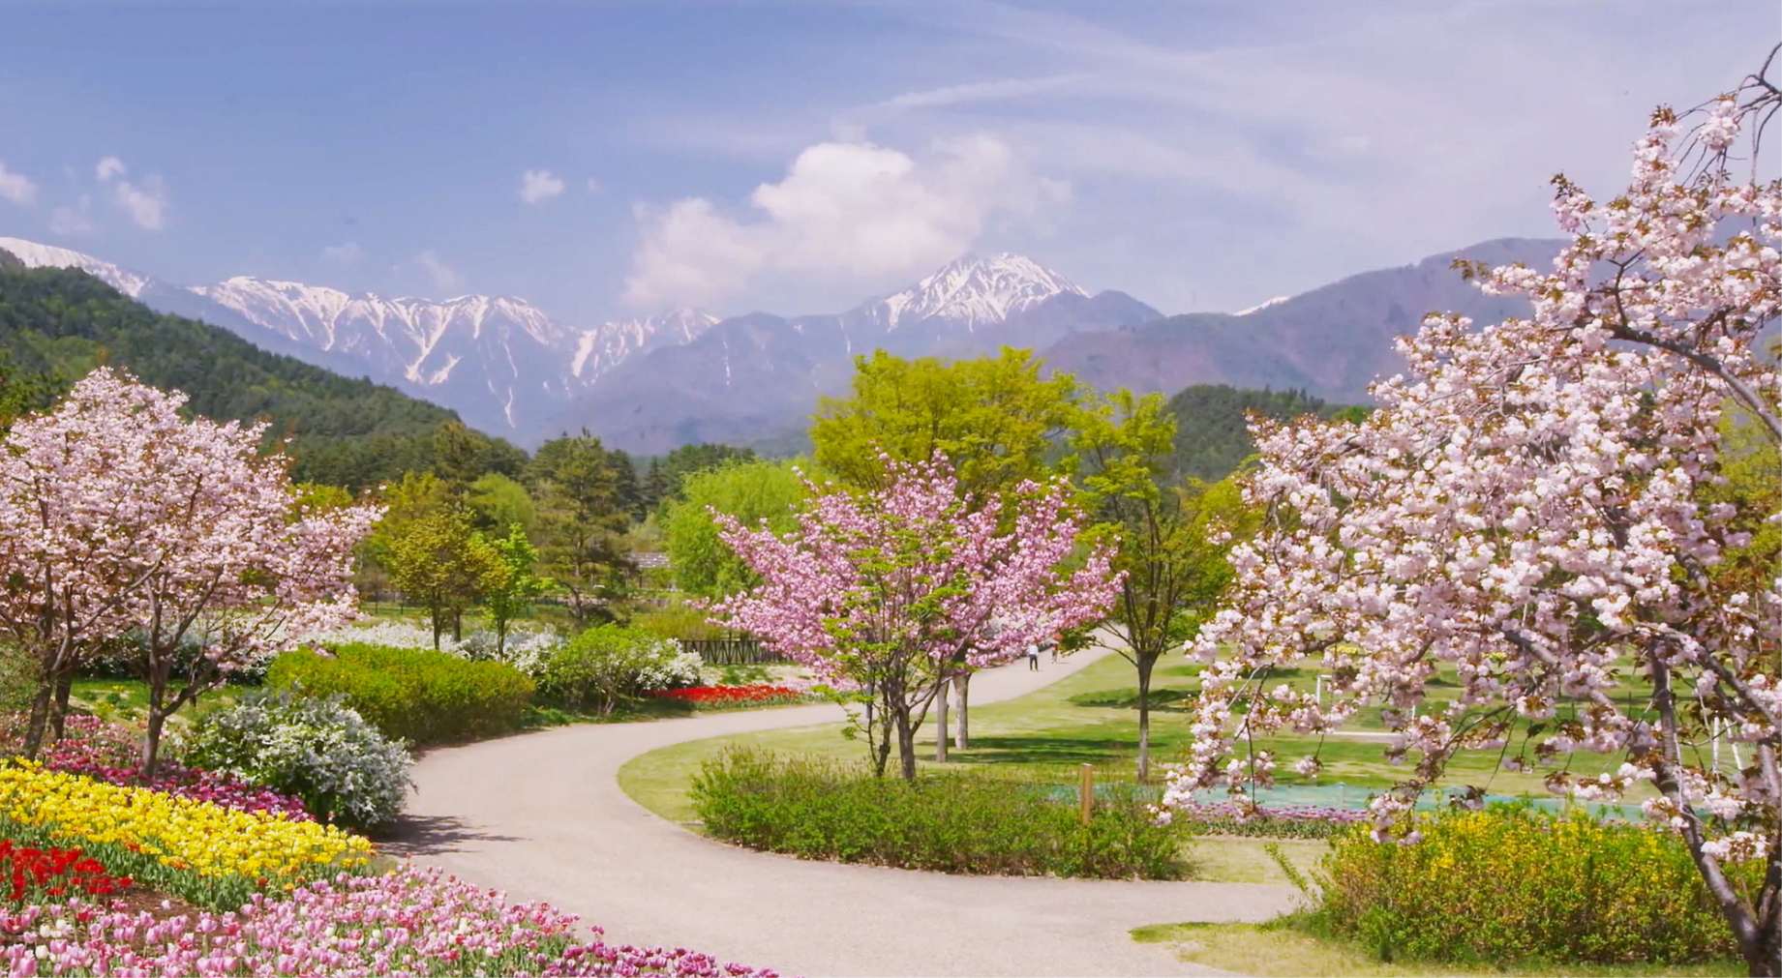
June
 | S | M | T | W | T | F | S
 |  |  | 1 | 2 | 3 | 4 | 5
 | 6 | 7 | 8 | 9 | 10 | 11 | 12
 | 13 | 14 | 15 | 16 | 17 | 18 | 19
 | 20 | 21 | 22 | 23 | 24 | 25 | 26
 | 27 | 28 | 29 | 30
 | Notes:
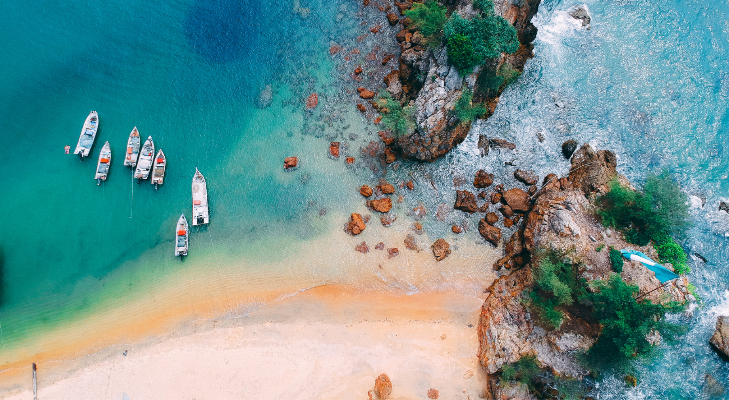
July

 | S | M | T | W | T | F | S
 |  |  |  |  | 1 | 2 | 3
 | 4 | 5 | 6 | 7 | 8 | 9 | 10
 | 11 | 12 | 13 | 14 | 15 | 16 | 17
 | 18 | 19 | 20 | 21 | 22 | 23 | 24
 | 25 | 26 | 27 | 28 | 29 | 30 | 31
 | Notes:

August
 | S | M | T | W | T | F | S
 | 1 | 2 | 3 | 4 | 5 | 6 | 7
 | 8 | 9 | 10 | 11 | 12 | 13 | 14
 | 15 | 16 | 17 | 18 | 19 | 20 | 21
 | 22 | 23 | 24 | 25 | 26 | 27 | 28
 | 29 | 30 | 31
 | Notes:
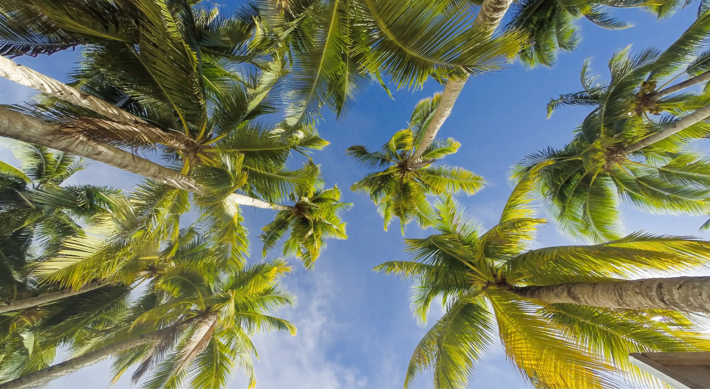
September
 | S | M | T | W | T | F | S
 |  |  |  | 1 | 2 | 3 | 4
 | 5 | 6 | 7 | 8 | 9 | 10 | 11
 | 12 | 13 | 14 | 15 | 16 | 17 | 18
 | 19 | 20 | 21 | 22 | 23 | 24 | 25
 | 26 | 27 | 28 | 29 | 30
 | Notes:
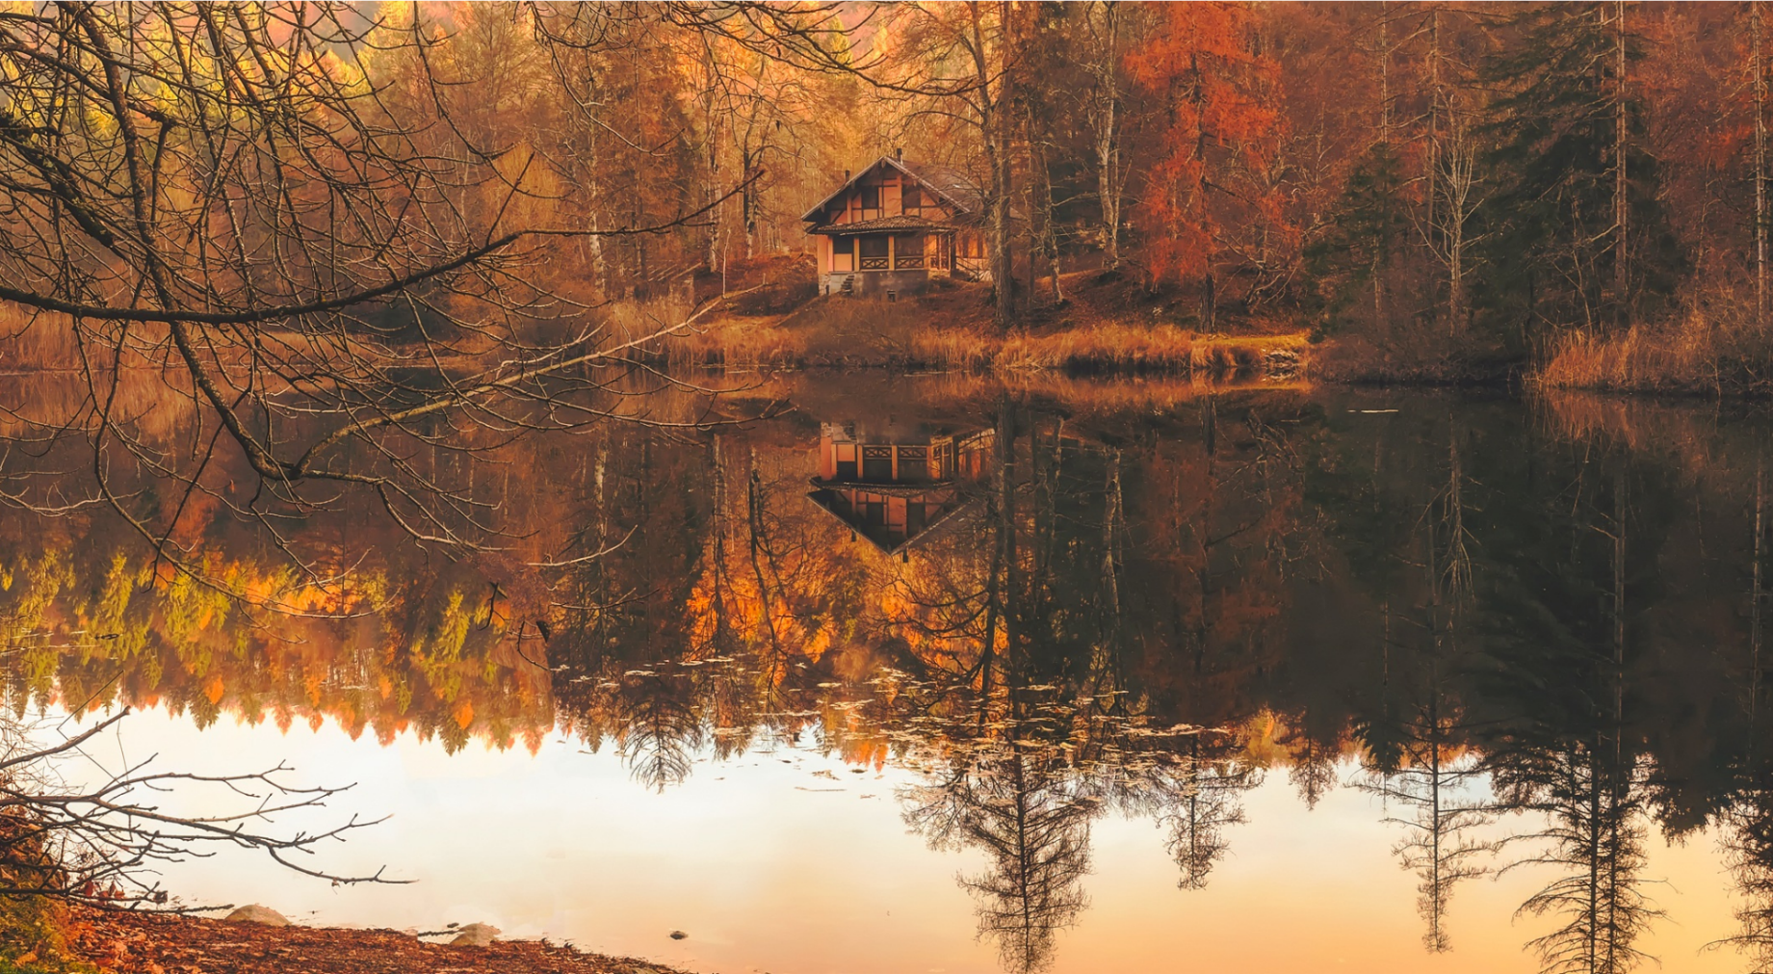
October
 | S | M | T | W | T | F | S
 |  |  |  |  |  | 1 | 2
 | 3 | 4 | 5 | 6 | 7 | 8 | 9
 | 10 | 11 | 12 | 13 | 14 | 15 | 16
 | 17 | 18 | 19 | 20 | 21 | 22 | 23
 | 24 | 25 | 26 | 27 | 28 | 29 | 30
 | 31
 | Notes:
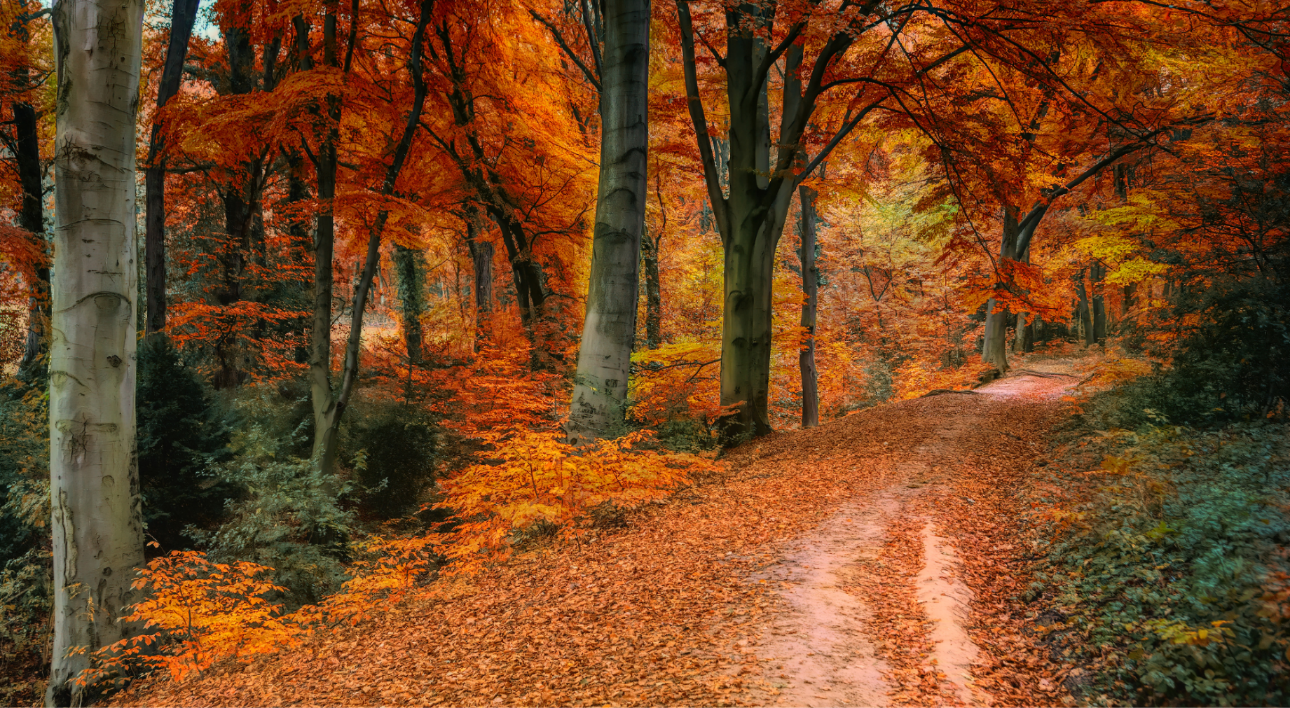
November
 | S | M | T | W | T | F | S
 |  | 1 | 2 | 3 | 4 | 5 | 6
 | 7 | 8 | 9 | 10 | 11 | 12 | 13
 | 14 | 15 | 16 | 17 | 18 | 19 | 20
 | 21 | 22 | 23 | 24 | 25 | 26 | 27
 | 28 | 29 | 30
 | Notes:
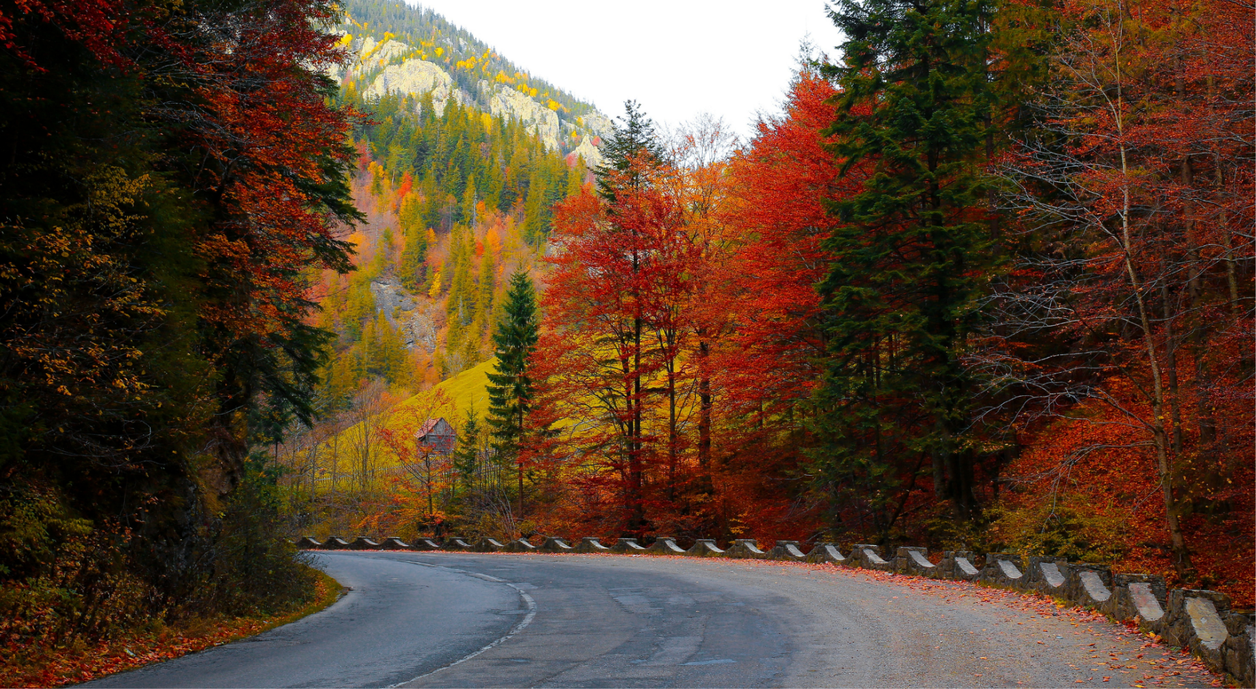
December
 | S | M | T | W | T | F | S
 |  |  |  | 1 | 2 | 3 | 4
 | 5 | 6 | 7 | 8 | 9 | 10 | 11
 | 12 | 13 | 14 | 15 | 16 | 17 | 18
 | 19 | 20 | 21 | 22 | 23 | 24 | 25
 | 26 | 27 | 28 | 29 | 30 | 31
 | Notes:
