2028
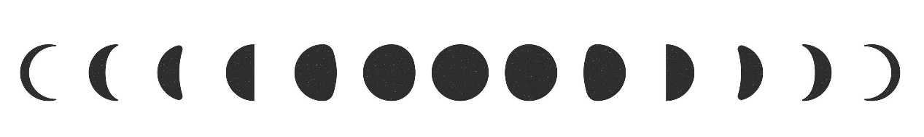
Lunar Calendar
January |  |  |  |  |  | February |  |  |  |  |  |  |  | March
 |  |  | 
12 | 05 | 26 | 18 |  |  |  | 10 | 03 |  | 25 | 17 |  |  | 11 | 04 | 11 | 17
April |  |  |  |  |  | May |  |  |  |  |  |  |  | June
09 | 02 | 24 | 16 |  |  | 08 | 02 | 24 |  | 16 | 31 |  |  | 06 | 29 | 22 | 15
July |  |  |  |  |  | August |  |  |  |  |  |  |  | September
06 | 28 | 22 | 14 |  |  |  | 05 | 27 |  | 20 | 13 |  |  | 03 | 25 | 18 | 12
October |  |  |  |  |  | November |  |  |  |  |  |  |  | December
 |  |  |  |  |  |  |  |  |  |  |  |  |  |  |  |  | 
03 | 25 | 18 | 11 |  |  |  | 02 | 24 |  | 16 | 09 |  | 02 | 23 | 16 | 09 | 31
 |  |  |  |  |  |  |  |  |  |  |  |  |  |  | 
Full Moon |  |  |  |  | First Quarter |  |  |  |  | New Moon |  |  |  |  | Last Quarter
Lunar & Solar Eclipse
Dec 31 (16:52) - Total Lunar Eclipse |  |  |  |  |  |  |  |  | Jan 26 (15:08) - Annual Solar Eclipse
Jul 28 (18:20) - Partial Lunar Eclipse |  |  |  |  |  |  |  |  | Jul 22 (02:56) - Total Solar Eclipse

