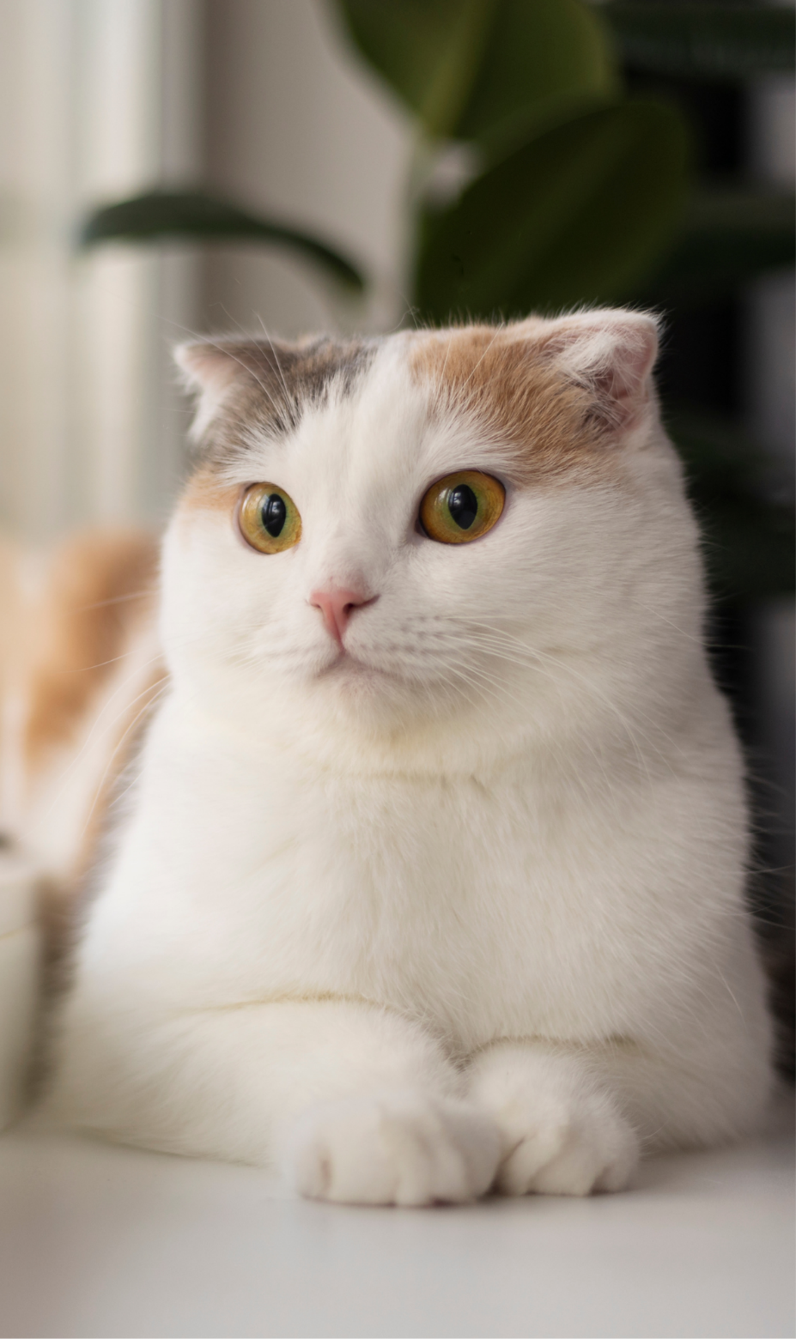
  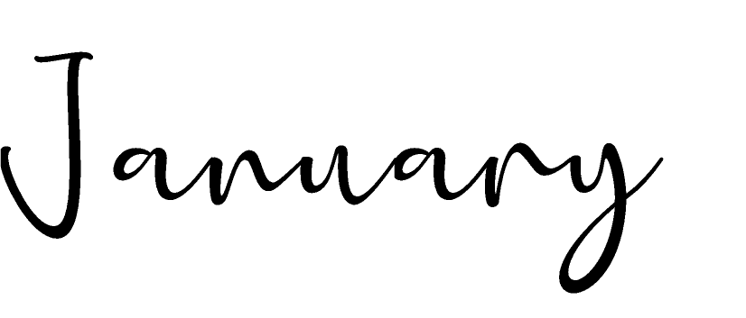
  2028
   | S | M | T | W | T | F | S
   |  |  |  |  |  |  | 1
   | 2 | 3 | 4 | 5 | 6 | 7 | 8
   | 9 | 10 | 11 | 12 | 13 | 14 | 15
   | 16 | 17 | 18 | 19 | 20 | 21 | 22
   | 23 | 24 | 25 | 26 | 27 | 28 | 29
   | 30 | 31
   | Notes:

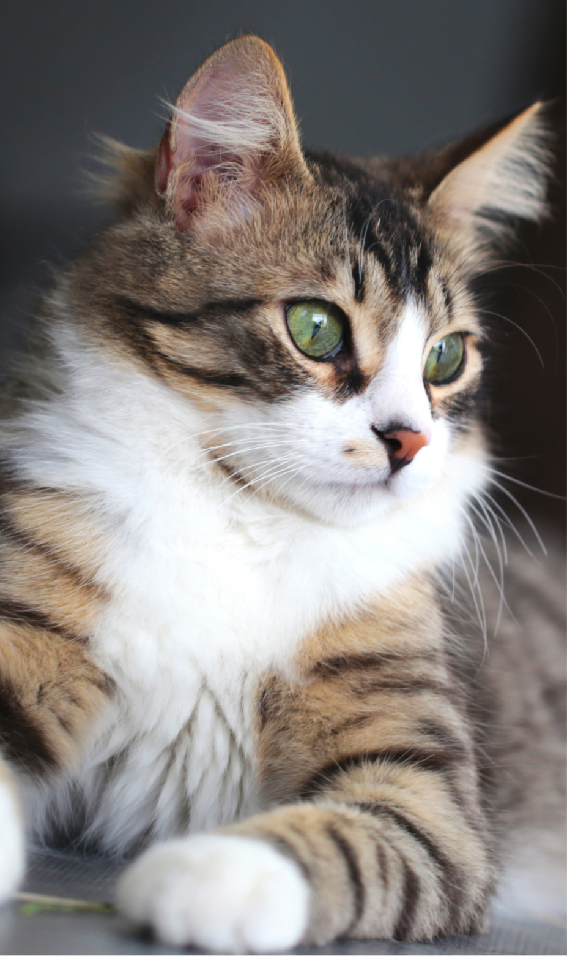
  
  2028
   | S | M | T | W | T | F | S
   |  |  | 1 | 2 | 3 | 4 | 5
   | 6 | 7 | 8 | 9 | 10 | 11 | 12
   | 13 | 14 | 15 | 16 | 17 | 18 | 19
   | 20 | 21 | 22 | 23 | 24 | 25 | 26
   | 27 | 28 | 29
   | Notes:

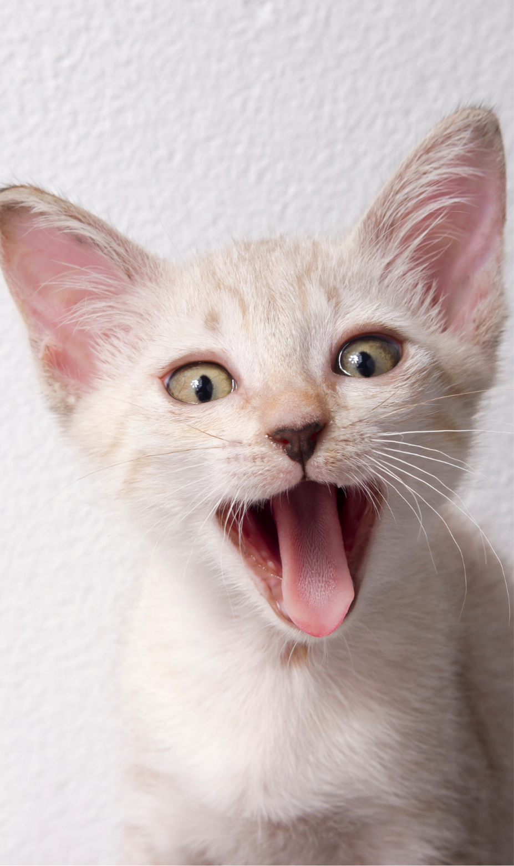
  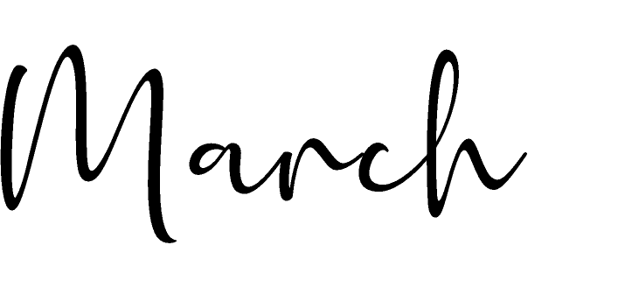
  2028
   | S | M | T | W | T | F | S
   |  |  |  | 1 | 2 | 3 | 4
   | 5 | 6 | 7 | 8 | 9 | 10 | 11
   | 12 | 13 | 14 | 15 | 16 | 17 | 18
   | 19 | 20 | 21 | 22 | 23 | 24 | 25
   | 26 | 27 | 28 | 29 | 30 | 31
   | Notes:

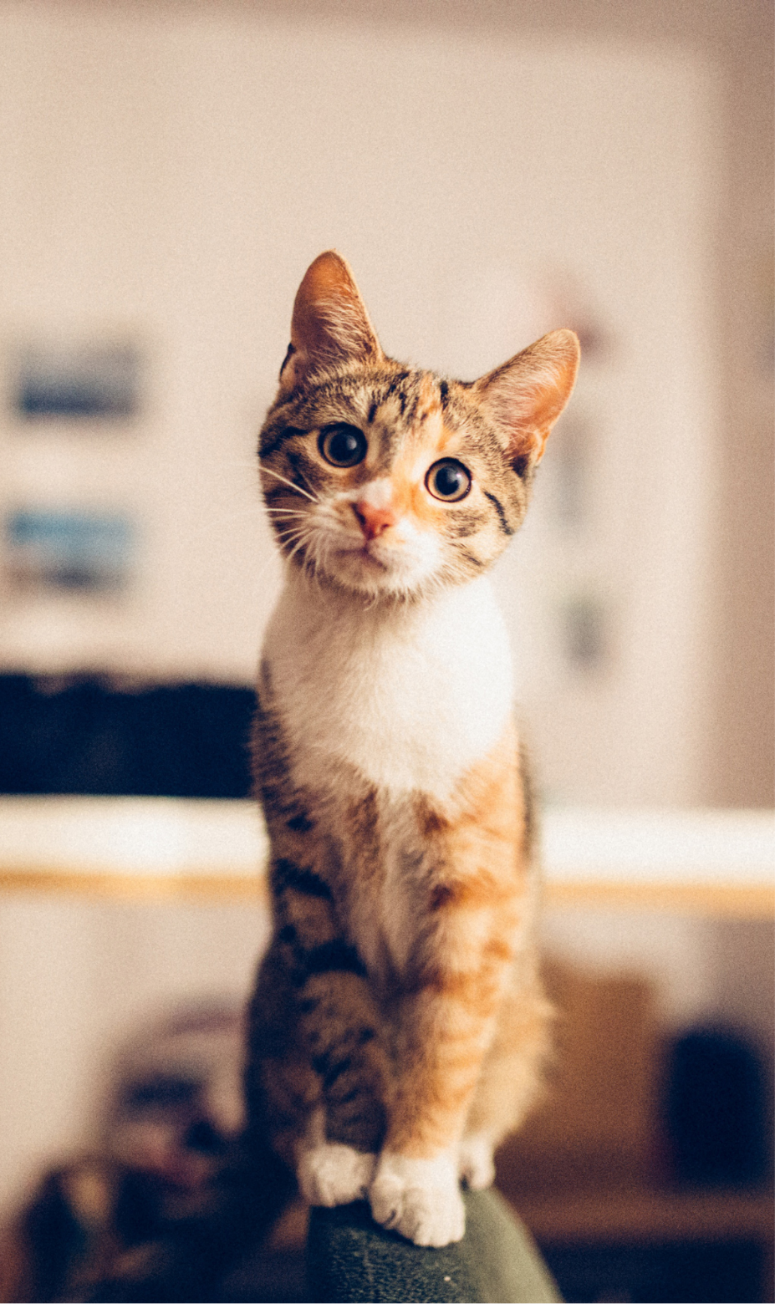
  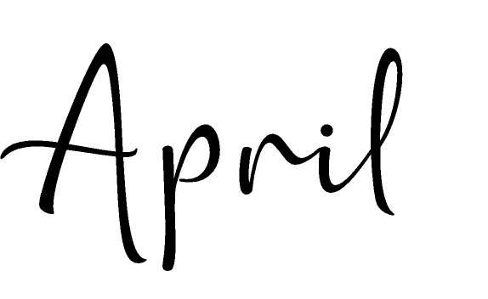
  2028
   | S | M | T | W | T | F | S
   |  |  |  |  |  |  | 1
   | 2 | 3 | 4 | 5 | 6 | 7 | 8
   | 9 | 10 | 11 | 12 | 13 | 14 | 15
   | 16 | 17 | 18 | 19 | 20 | 21 | 22
   | 23 | 24 | 25 | 26 | 27 | 28 | 29
   | 30
   | Notes:

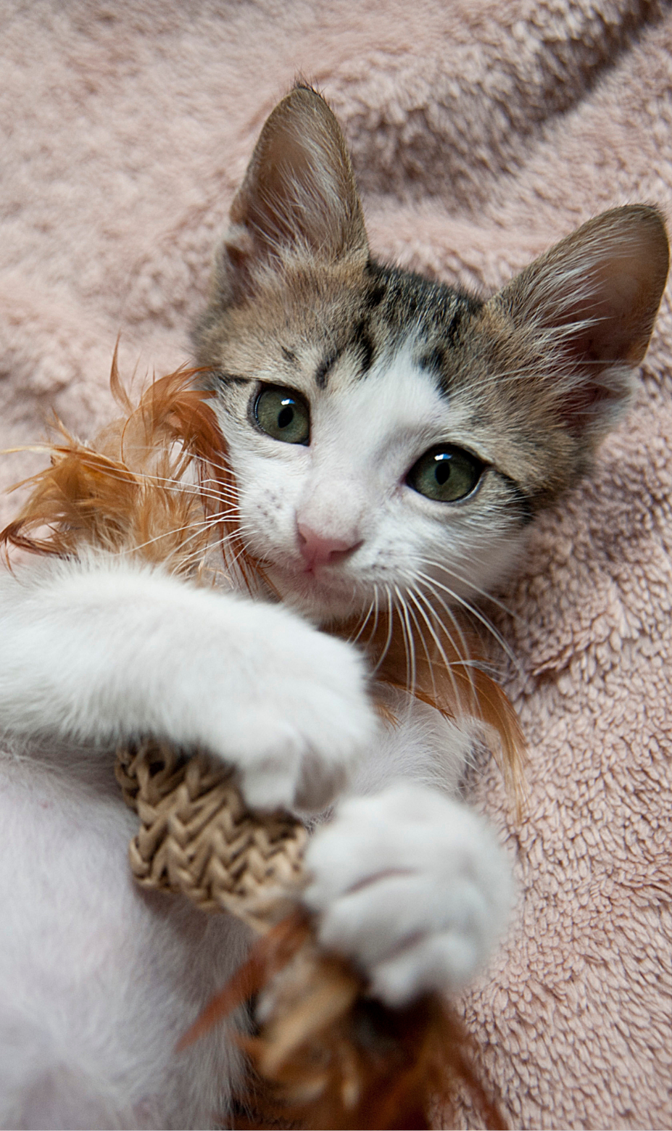
  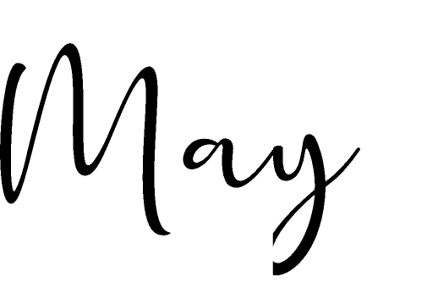
  2028
   | S | M | T | W | T | F | S
   |  | 1 | 2 | 3 | 4 | 5 | 6
   | 7 | 8 | 9 | 10 | 11 | 12 | 13
   | 14 | 15 | 16 | 17 | 18 | 19 | 20
   | 21 | 22 | 23 | 24 | 25 | 26 | 27
   | 28 | 29 | 30 | 31
   | Notes:

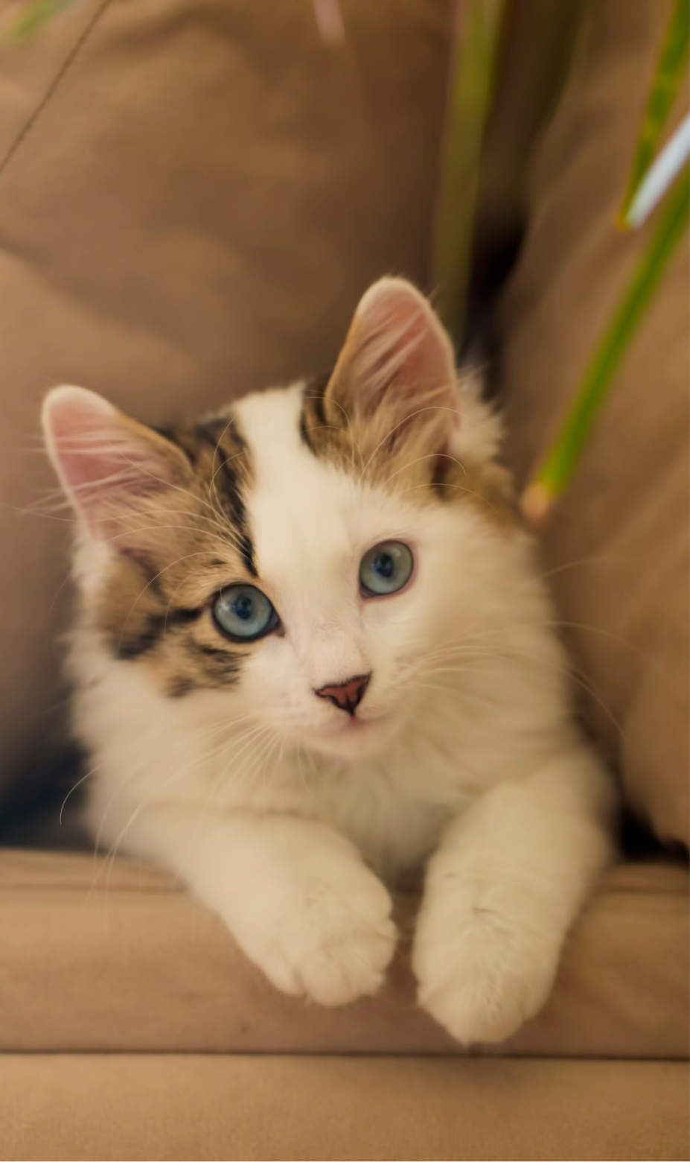
  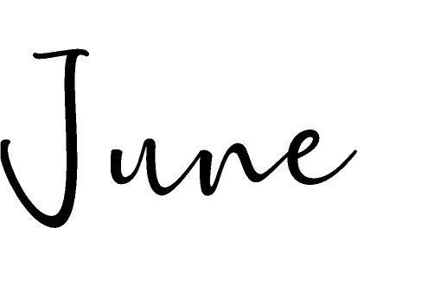
  2028
   | S | M | T | W | T | F | S
   |  |  |  |  | 1 | 2 | 3
   | 4 | 5 | 6 | 7 | 8 | 9 | 10
   | 11 | 12 | 13 | 14 | 15 | 16 | 17
   | 18 | 19 | 20 | 21 | 22 | 23 | 24
   | 25 | 26 | 27 | 28 | 29 | 30
   | Notes:

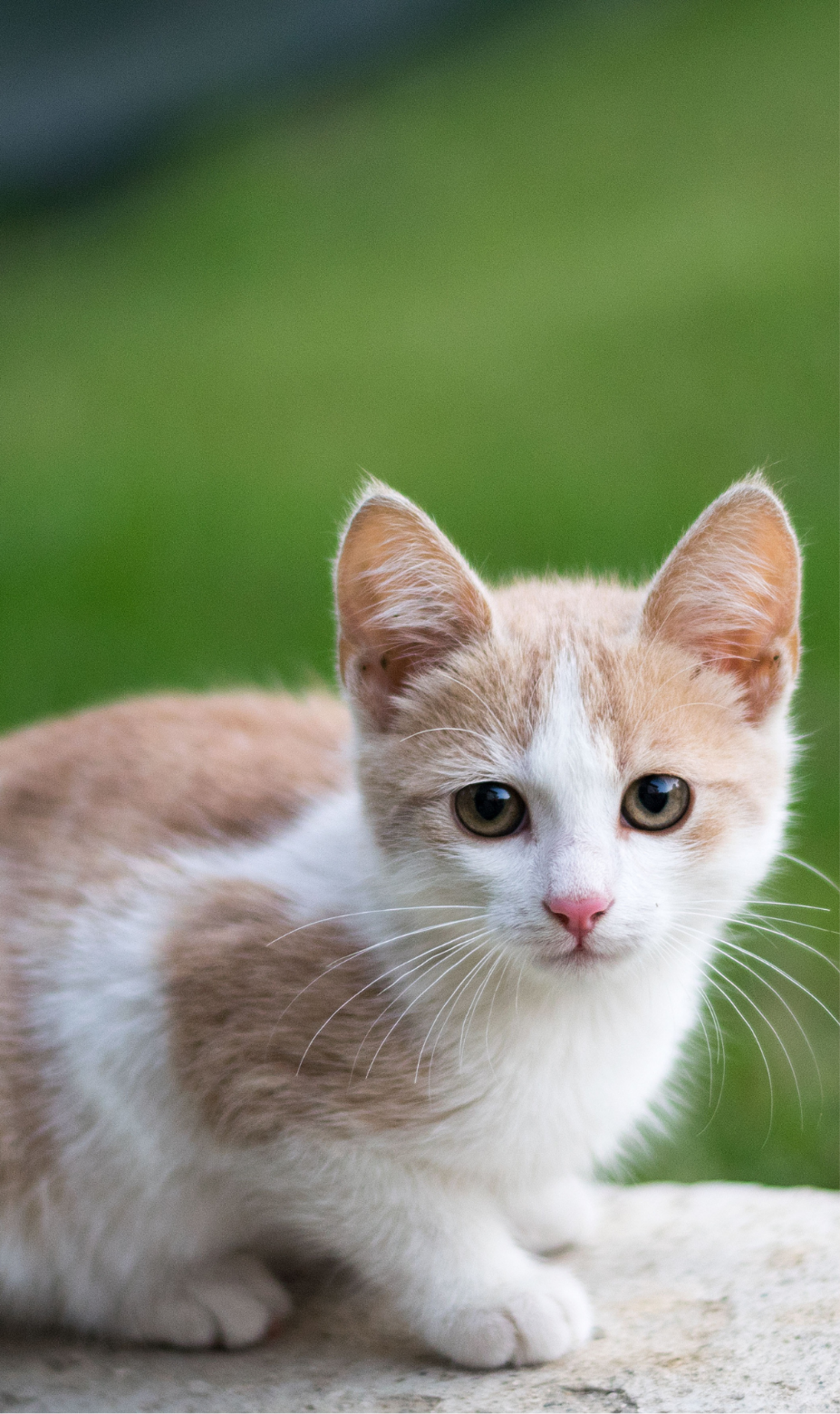
  
  2028
   | S | M | T | W | T | F | S
   |  |  |  |  |  |  | 1
   | 2 | 3 | 4 | 5 | 6 | 7 | 8
   | 9 | 10 | 11 | 12 | 13 | 14 | 15
   | 16 | 17 | 18 | 19 | 20 | 21 | 22
   | 23 | 24 | 25 | 26 | 27 | 28 | 29
   | 30 | 31
   | Notes:

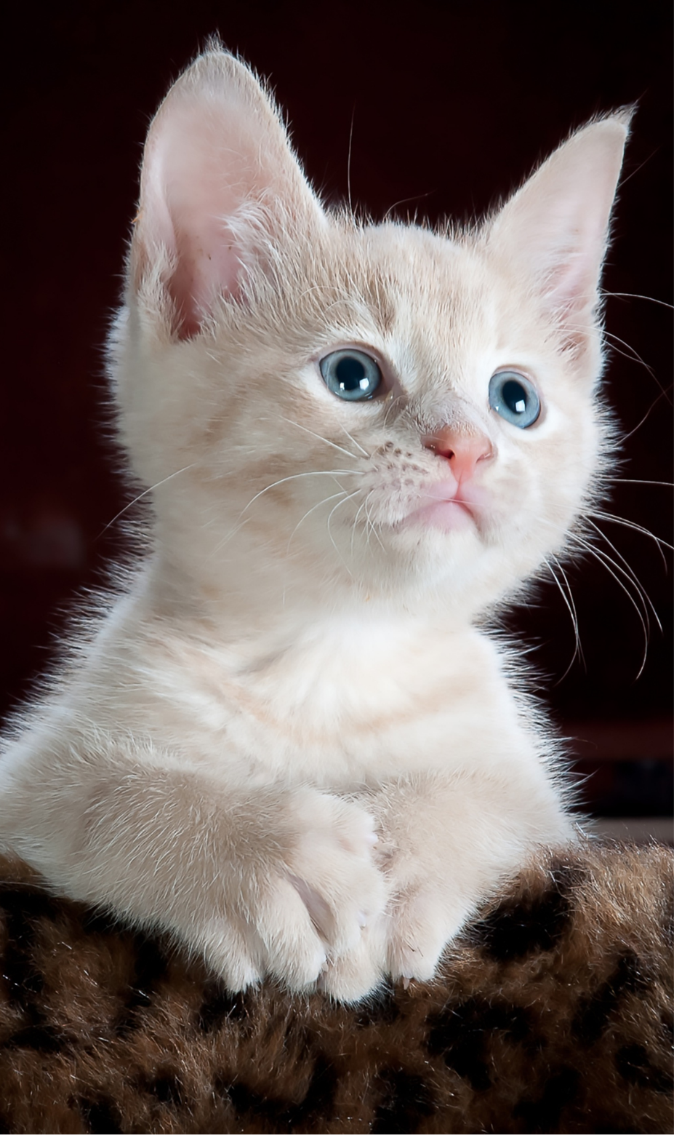
  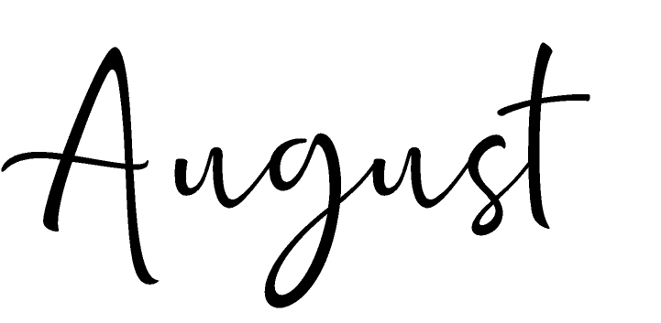
  2028
   | S | M | T | W | T | F | S
   |  |  | 1 | 2 | 3 | 4 | 5
   | 6 | 7 | 8 | 9 | 10 | 11 | 12
   | 13 | 14 | 15 | 16 | 17 | 18 | 19
   | 20 | 21 | 22 | 23 | 24 | 25 | 26
   | 27 | 28 | 29 | 30 | 31
   | Notes:

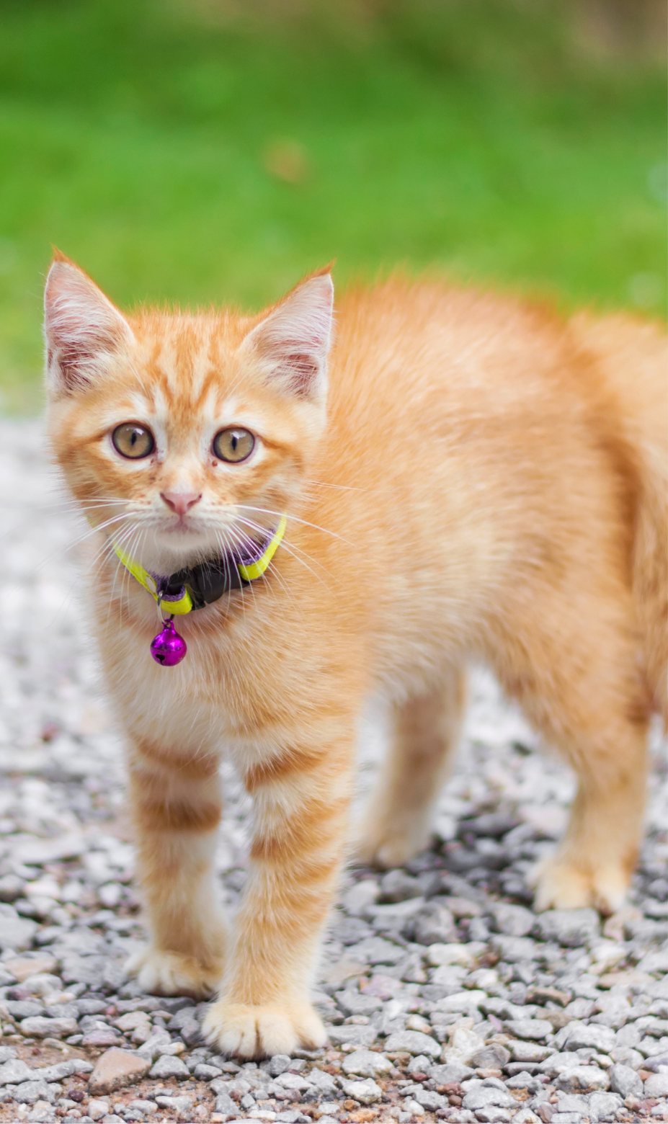
  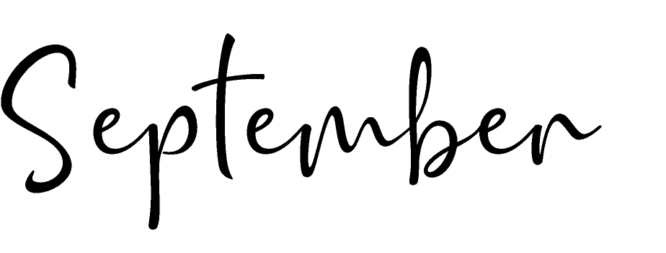
  2028
   | S | M | T | W | T | F | S
   |  |  |  |  |  | 1 | 2
   | 3 | 4 | 5 | 6 | 7 | 8 | 9
   | 10 | 11 | 12 | 13 | 14 | 15 | 16
   | 17 | 18 | 19 | 20 | 21 | 22 | 23
   | 24 | 25 | 26 | 27 | 28 | 29 | 30
   | Notes:

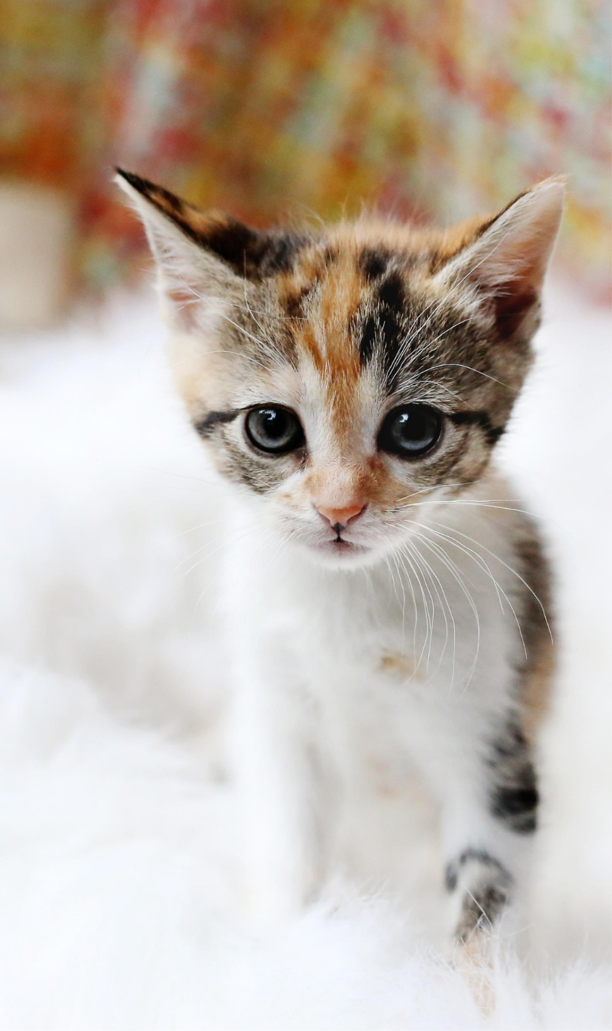
  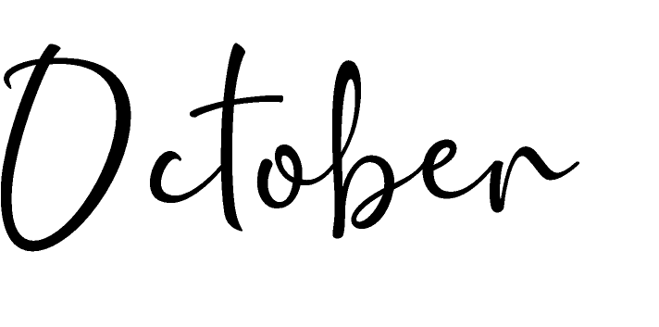
  2028
   | S | M | T | W | T | F | S
   | 1 | 2 | 3 | 4 | 5 | 6 | 7
   | 8 | 9 | 10 | 11 | 12 | 13 | 14
   | 15 | 16 | 17 | 18 | 19 | 20 | 21
   | 22 | 23 | 24 | 25 | 26 | 27 | 28
   | 29 | 30 | 31
   | Notes:

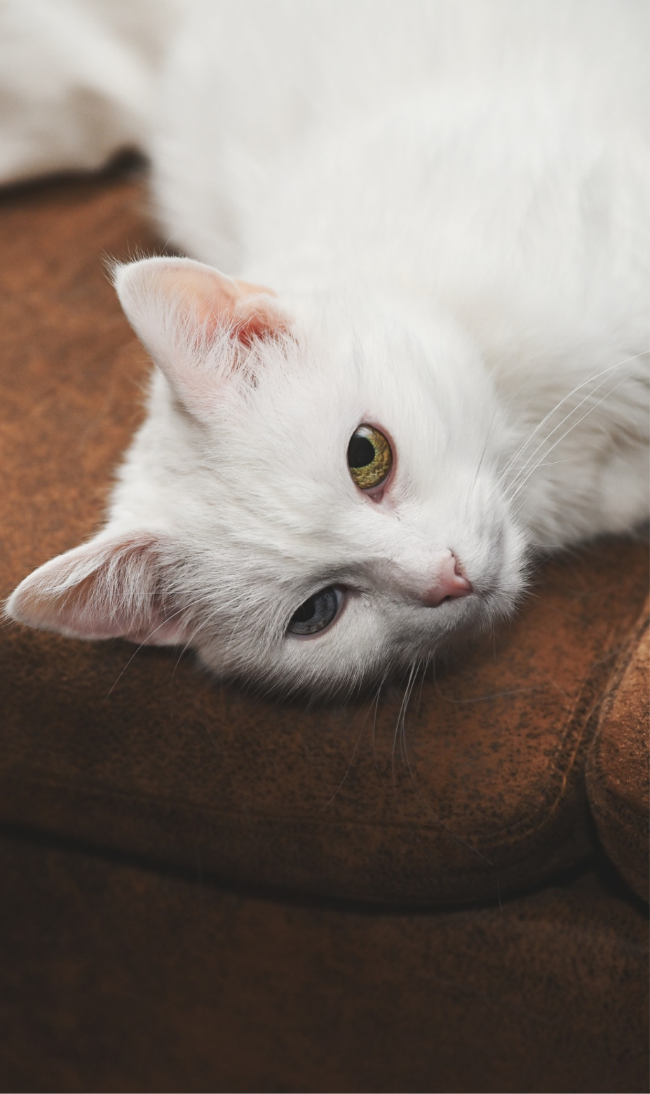
  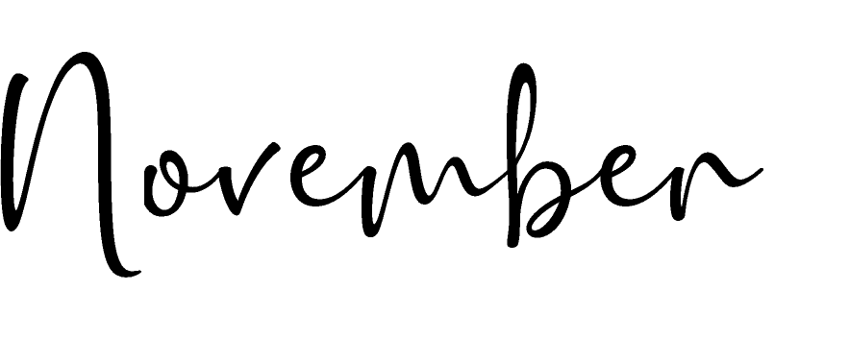
  2028
   | S | M | T | W | T | F | S
   |  |  |  | 1 | 2 | 3 | 4
   | 5 | 6 | 7 | 8 | 9 | 10 | 11
   | 12 | 13 | 14 | 15 | 16 | 17 | 18
   | 19 | 20 | 21 | 22 | 23 | 24 | 25
   | 26 | 27 | 28 | 29 | 30
   | Notes:

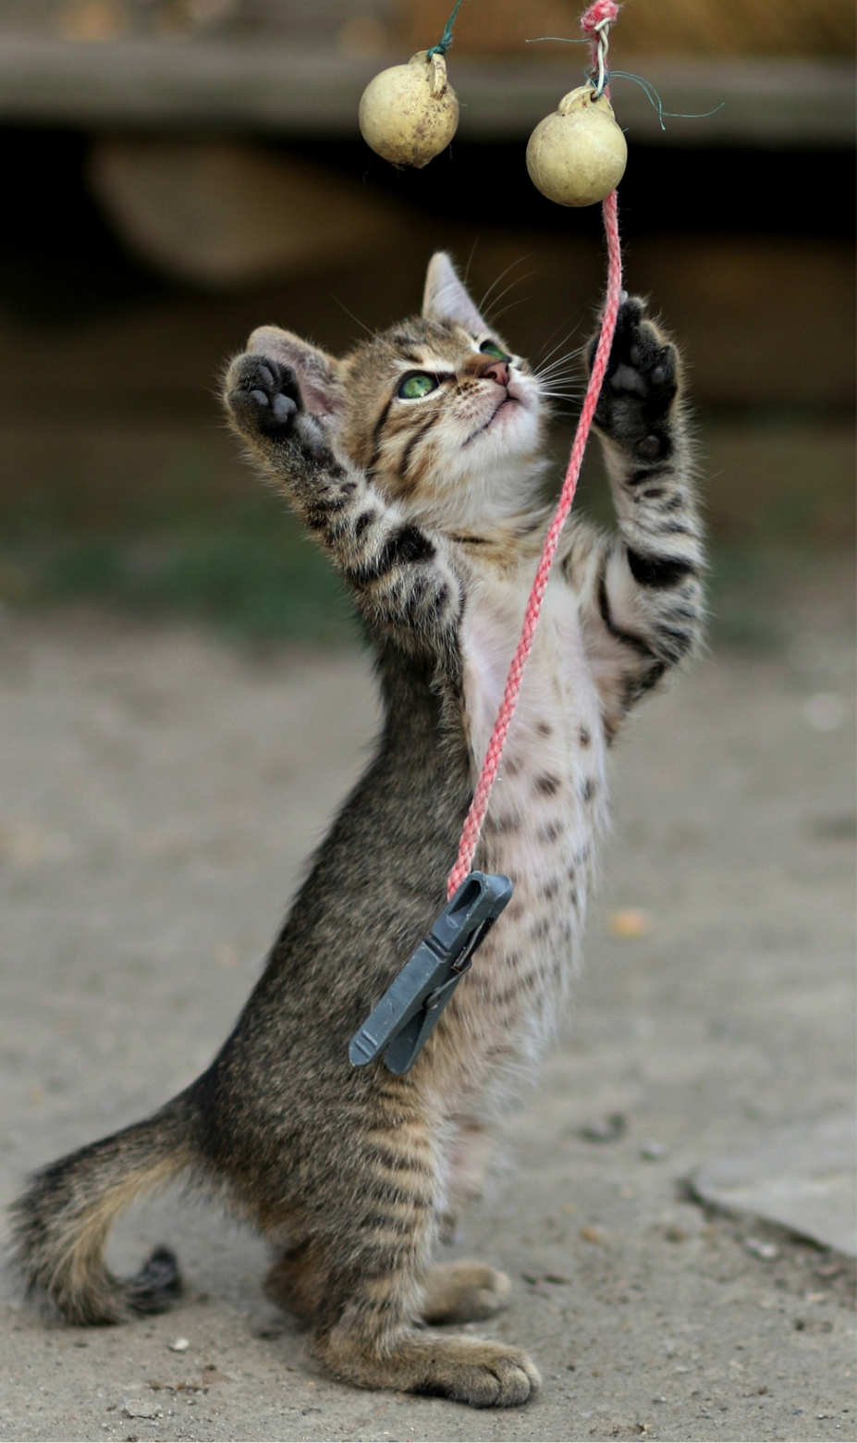
  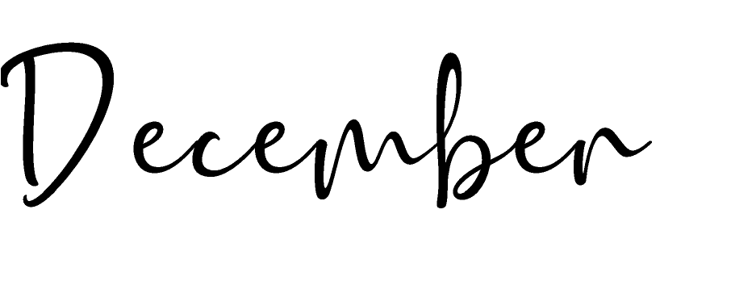
  2028
   | S | M | T | W | T | F | S
   |  |  |  |  |  | 1 | 2
   | 3 | 4 | 5 | 6 | 7 | 8 | 9
   | 10 | 11 | 12 | 13 | 14 | 15 | 16
   | 17 | 18 | 19 | 20 | 21 | 22 | 23
   | 24 | 25 | 26 | 27 | 28 | 29 | 30
   | 31
   | Notes:

