Annual Flower Planting Calendar

Variety | Indoor Sowing Date | Days to Max Germination | Planting Depth | Weeks to Transplant | Soil Temperature (℉)
Ageratum | December-March | 7 | 1/8 inch | 8-10 | 75-78
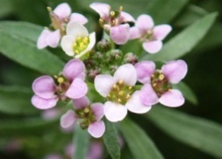  Alyssum | December-March | 8 | 1/6 inch | 10-12 | 78-82
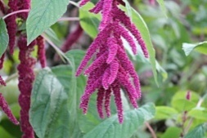  Amaranthus | December-March | 14 | 1/2 inch | 7-9 | 68-70
Aster | January-April | 8 | 1/8 inch | 8 | 70-75
Bachelor Button | February-March | 8 | 1/4 inch | 4-6 | 68-70
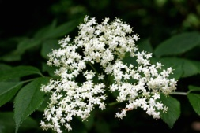  Baby’s Breath | February-March | 8 | 1/4 inch | 6-8 | 68-72
Celosia | January-April | 10 | 1/8 inch | 6 | 70-80
5  Coleus | December-March | 10 | 1/4 inch | 6-9 | 70-75
Cosmos | January-April | 5 | 1/4 inch | 6 | 68-72
Daisies | February- March | 8 | 1/4 inch | 5-6 | 70-75
Geraniums | November-February | 4-10 | 1/2 inch | 14-16 | 70-75
Impatiens | December-March | 15 | 1/8 inch | 10-12 | 68-72
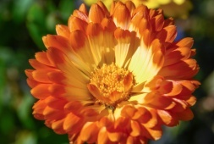  Marigolds | January-April | 7 | 1/8 inch | 6-9 | 70-80
Moon Flower | February-March | 8 | 1/4 inch | 6-8 | 70-75
Morning Glory | February-March | 8 | 1/4 inch | 4-5 | 70-75
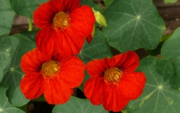  Nasturtium | February-March | 8 | 1/2 inch | 6 | 70-74
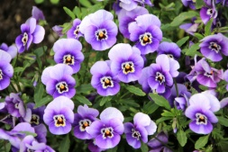  Pansy | November-February | 16 | 1/8 inch | 6-10 | 55-65
Petunia | December-March | 10 | top | 10 | 70-80
Salvia | December-March | 15 | 1/10 inch | 9 | 75-78
Sunflower | February-March | 6 | 1 | N/A | 70-80
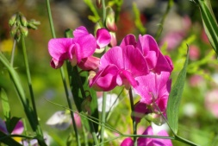  Sweet Pea | February-March | 8 | 1 | 4-6 | 70-75
Vinca | December-March | 15 | 1/4 inch | 12 | 70-80
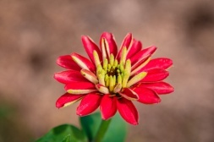  Zinnias | January-April | 7 | 1/8 inch | 5-8 | 68-72

