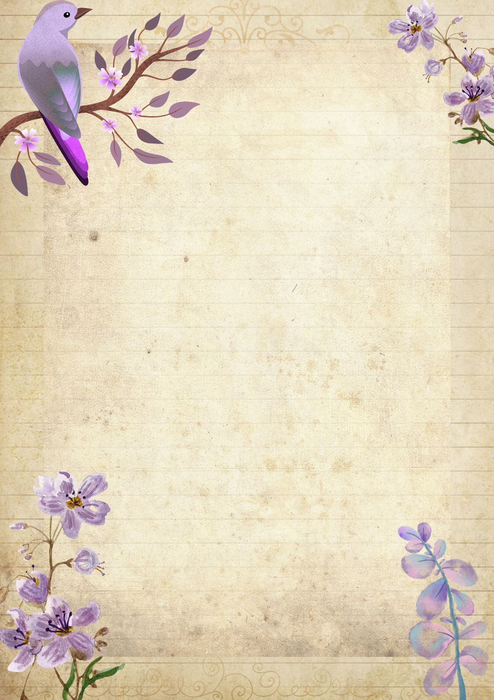
Quiet Thoughts

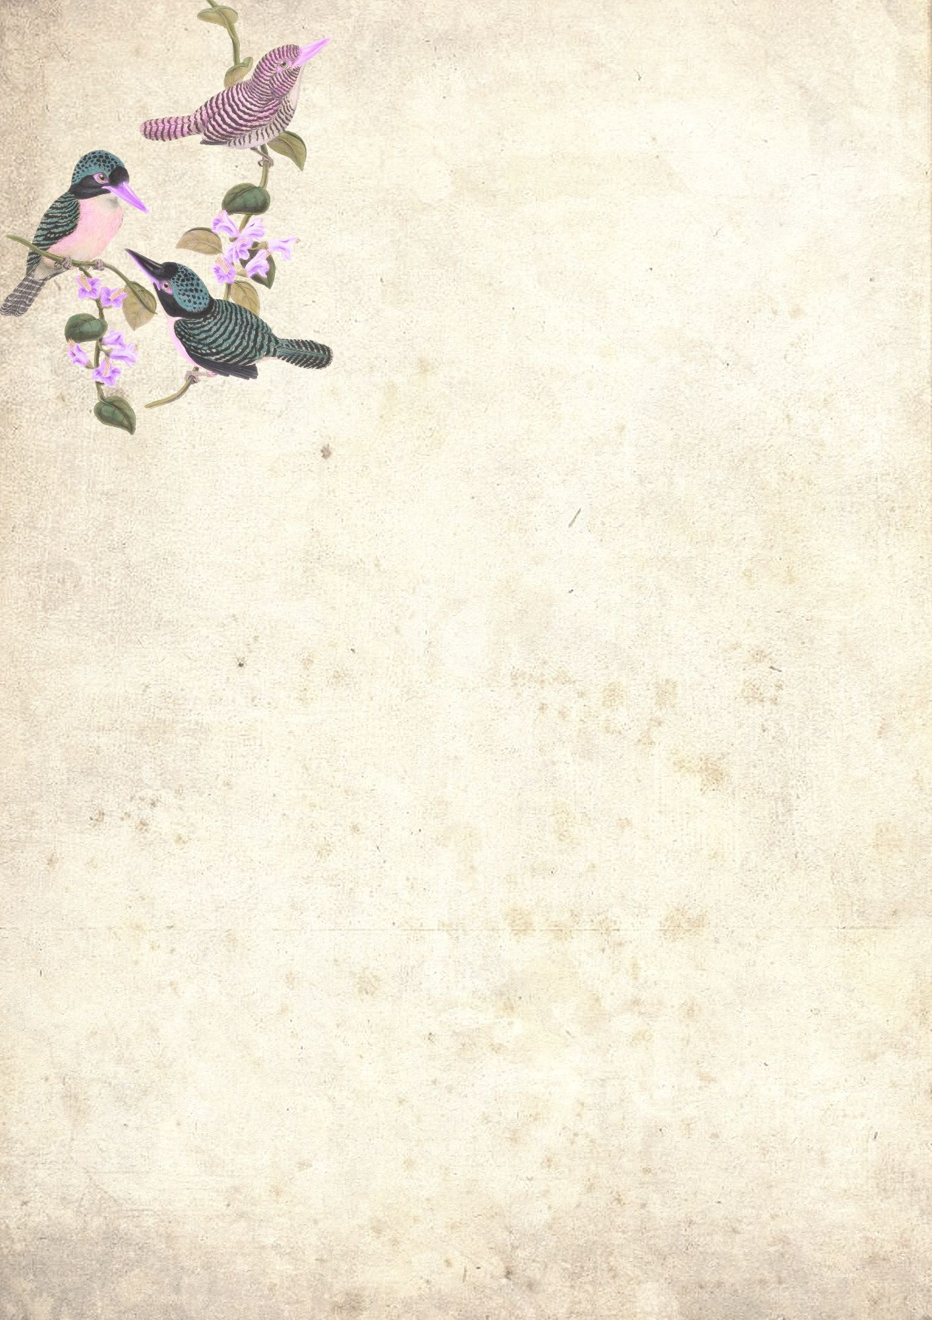
Collage

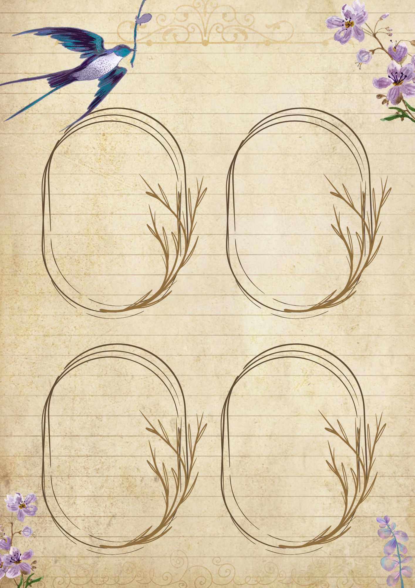
Gratitiude

To Remember

My Mood

Little Joys

Today’s Highlights

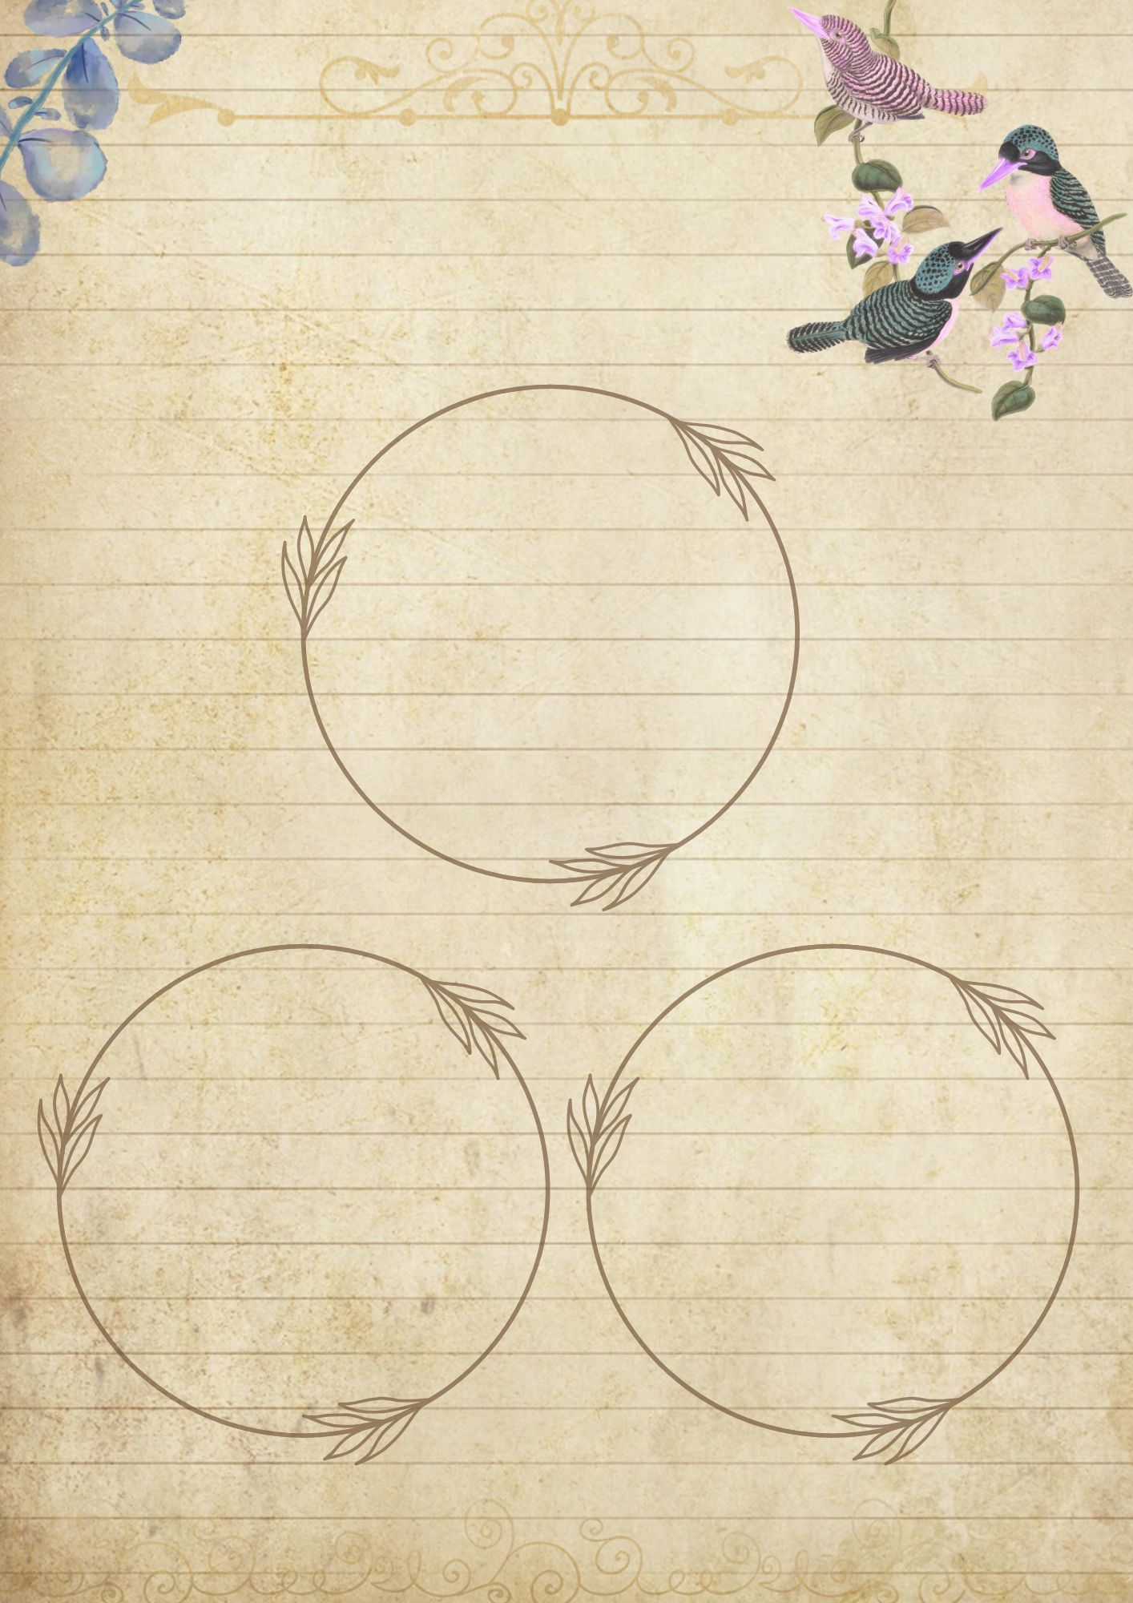
Keepsakes

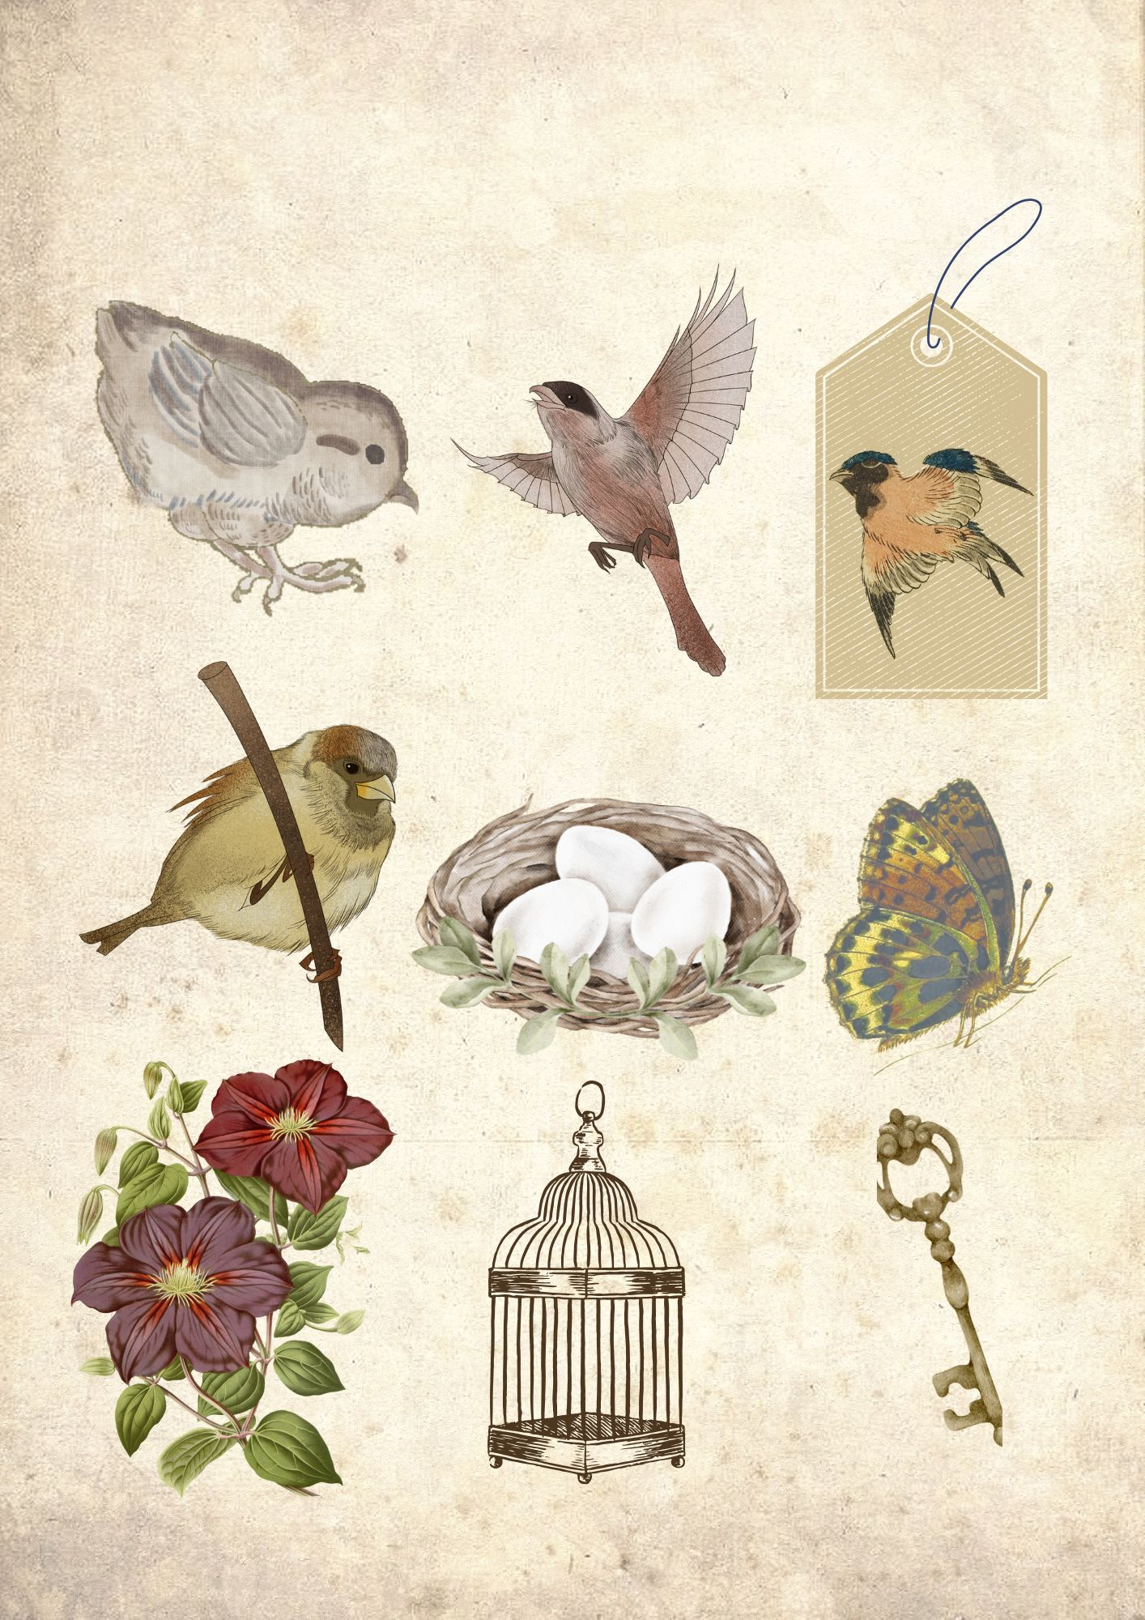
Cut & Use in your journal

Birds Fussy Cuts

