
Collage / Sketching


Thoughts I want to Keep

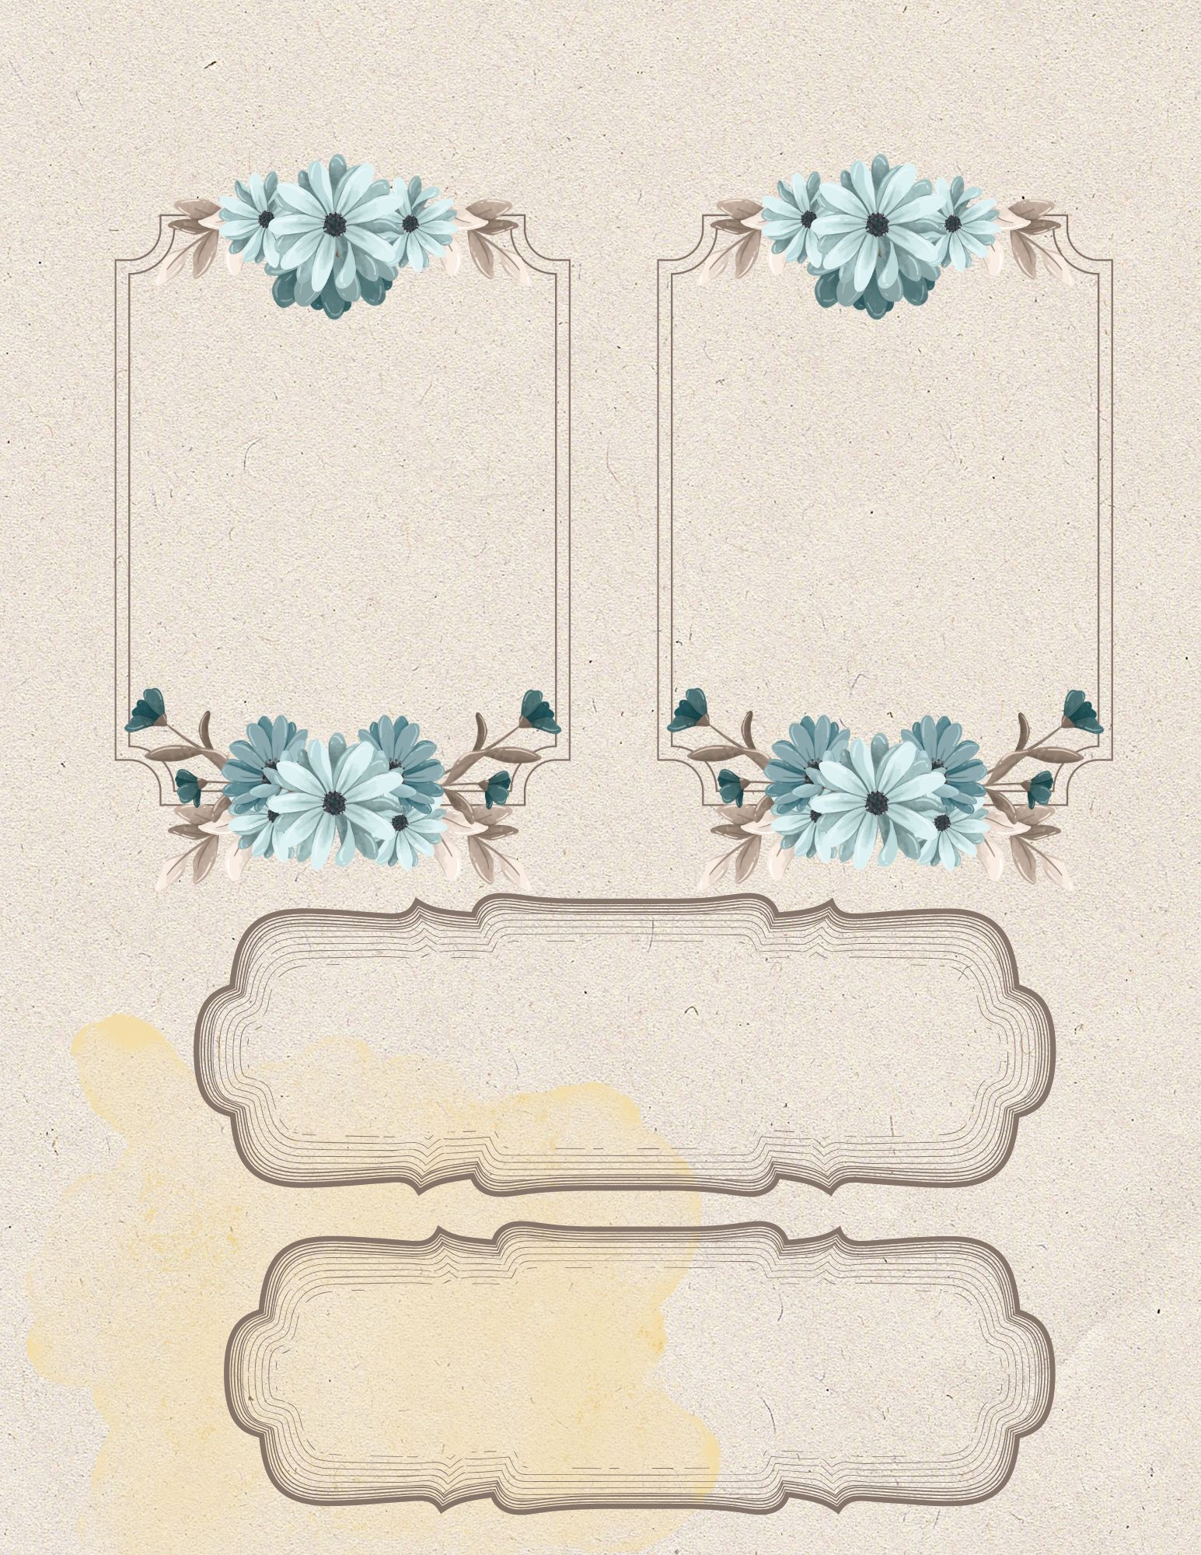

Mood of the Day

Today’s Highlights

Gratitude

To Remember

Little Joys

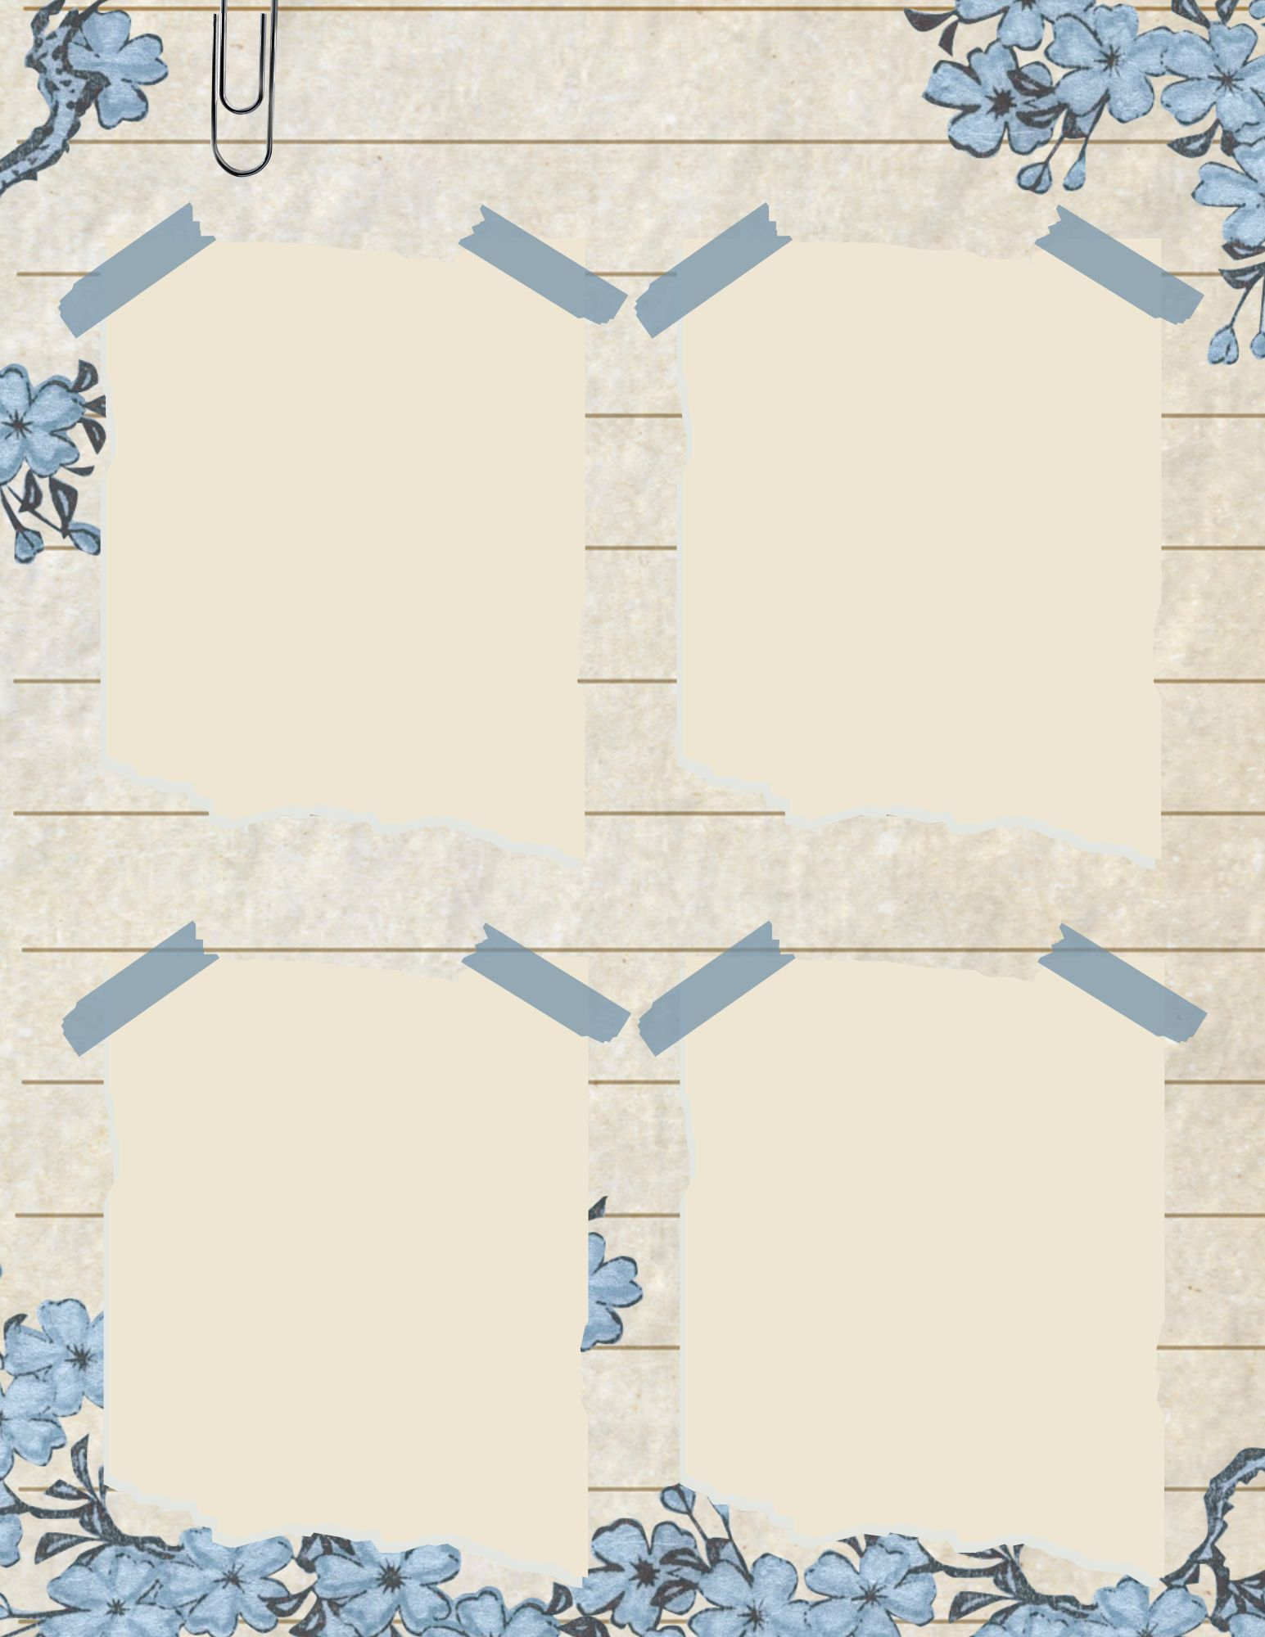
Date:
Place:
Why I saved this:

Date:
Place:
Why I saved this:

Date:
Place:
Why I saved this:

Date:
Place:
Why I saved this:

Keepsakes

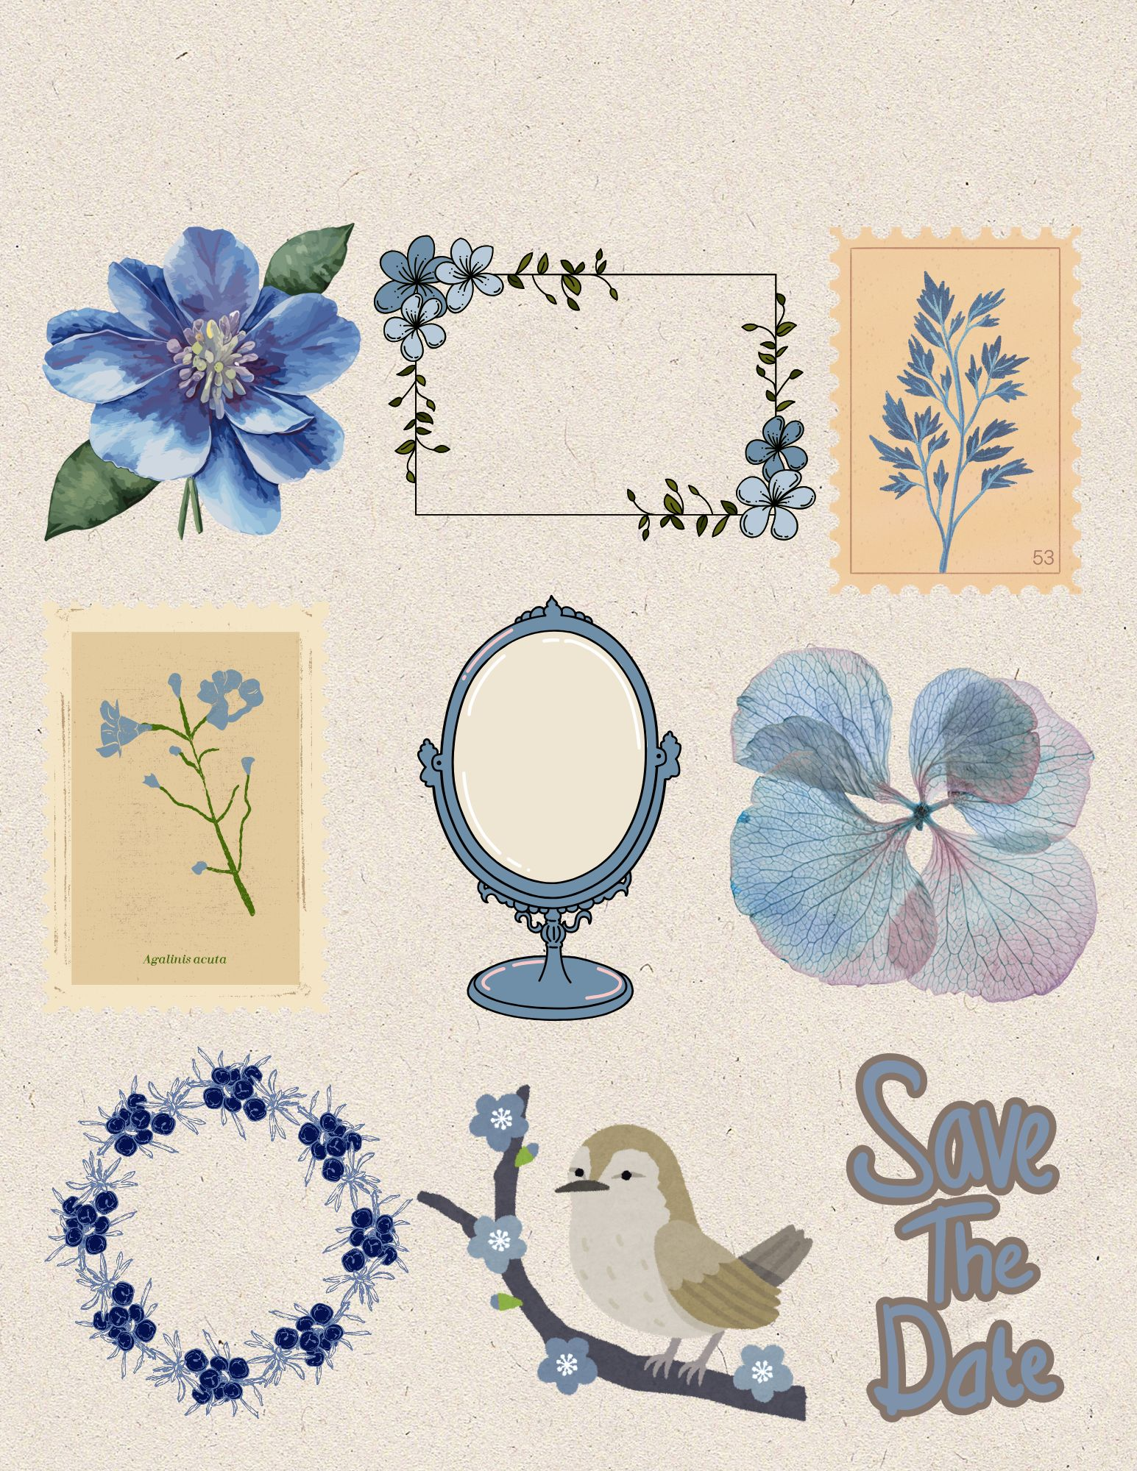
Trim & Use in your journal

Botanical Blue Fussy Cuts

