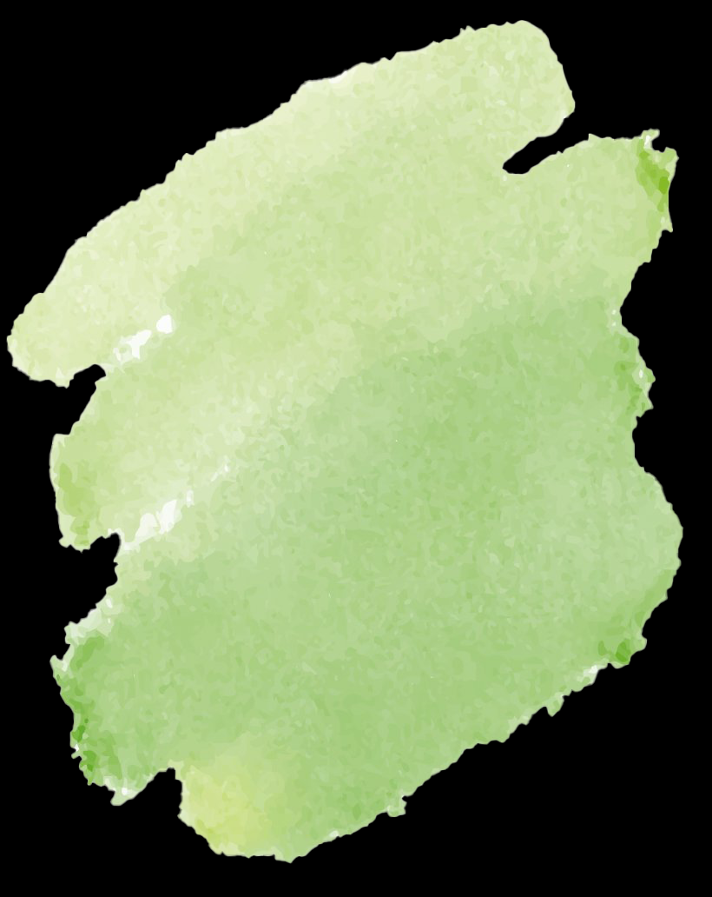
Garden Organizer
Crop/Plant | Season | Bed/Row | Next Plant | Additional Notes

