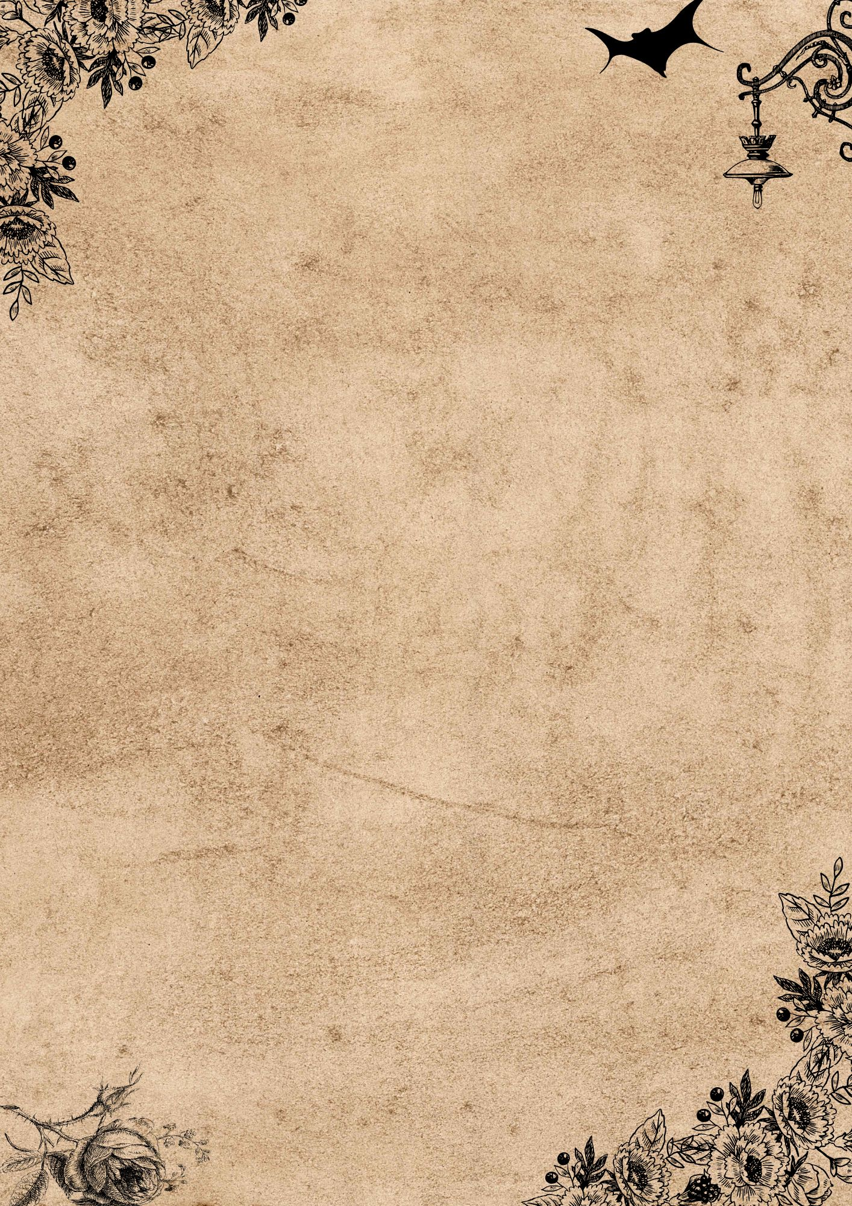

Collage / Sketching

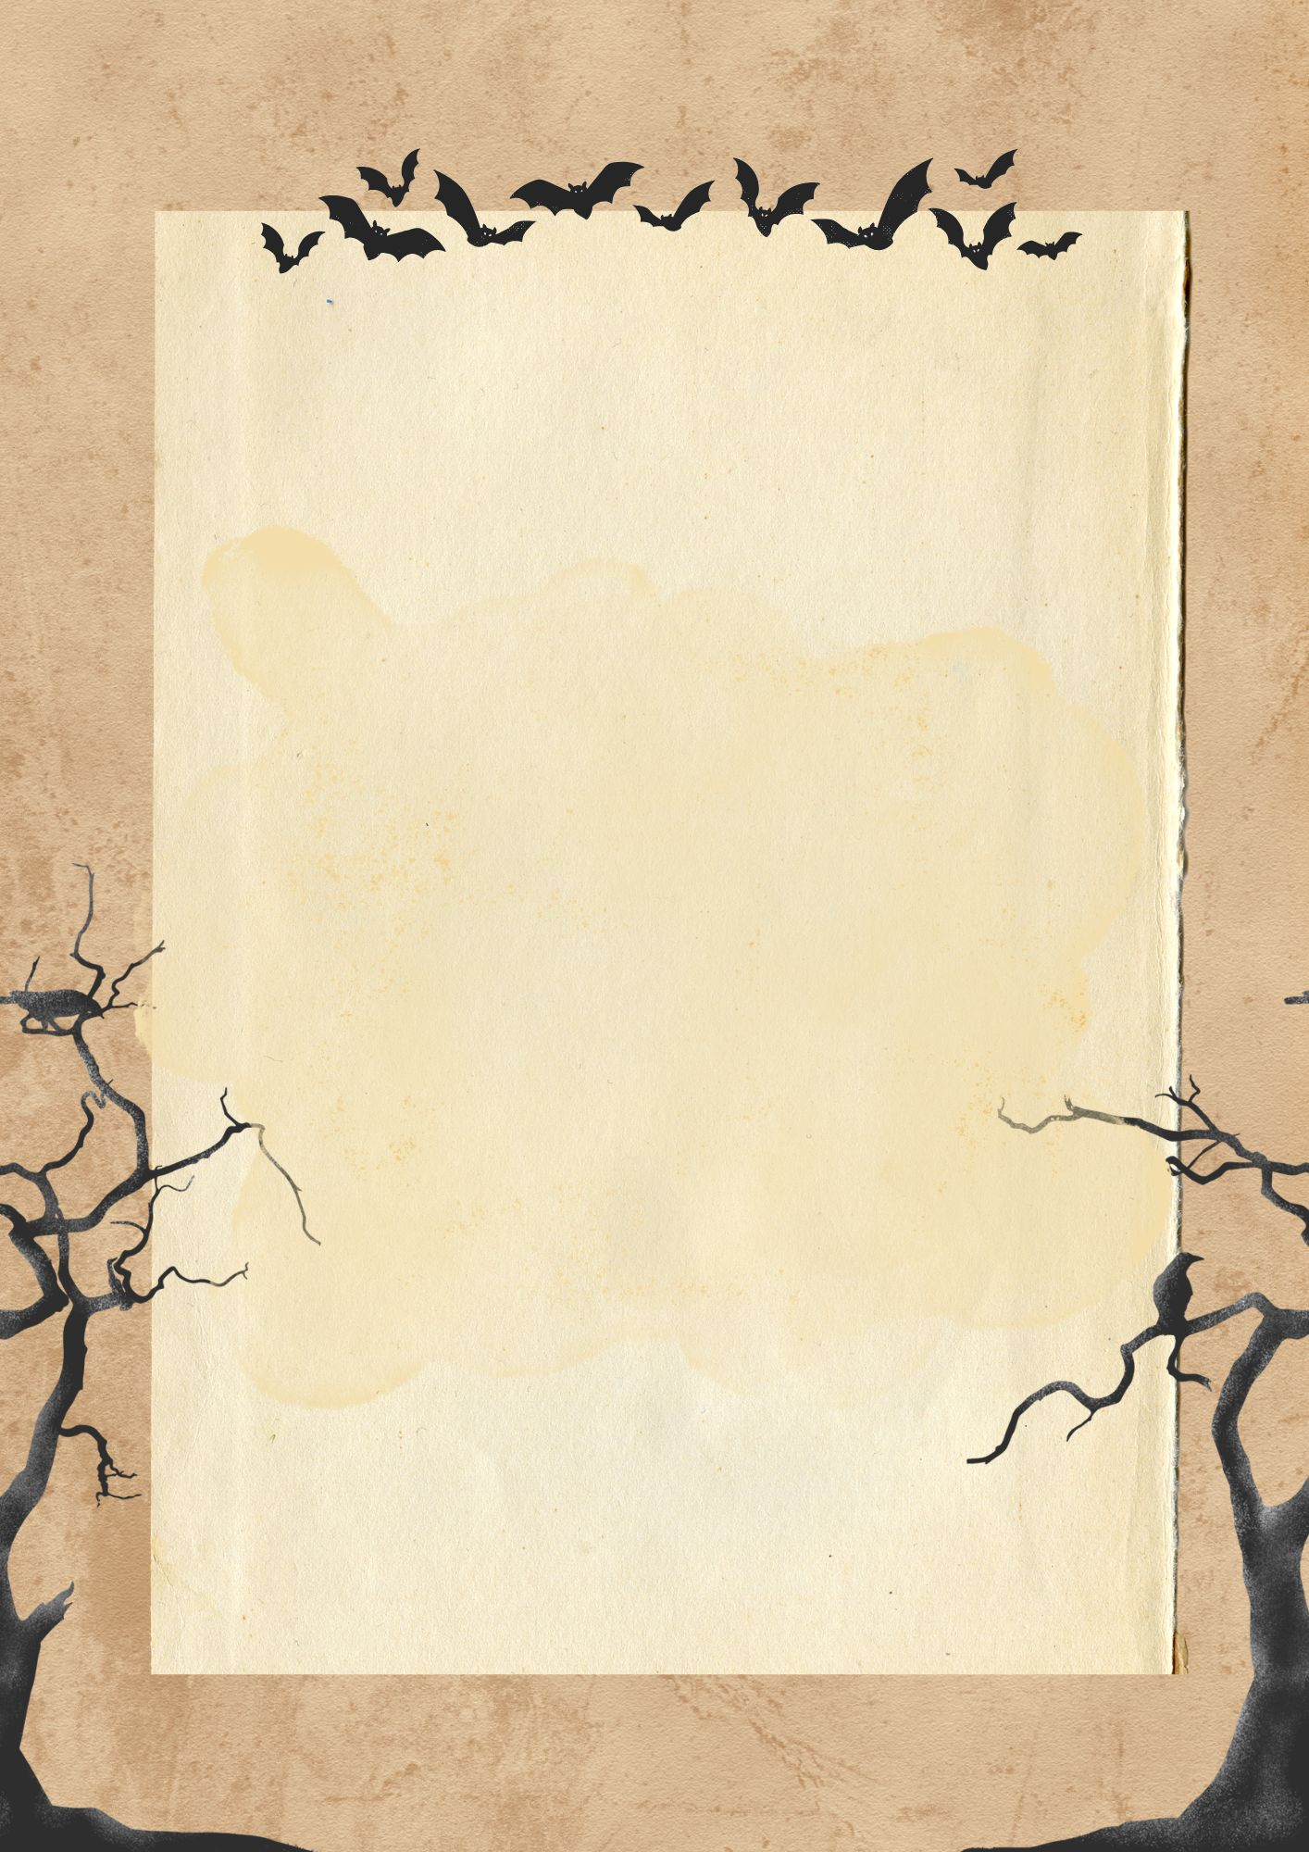

Whispers on Paper

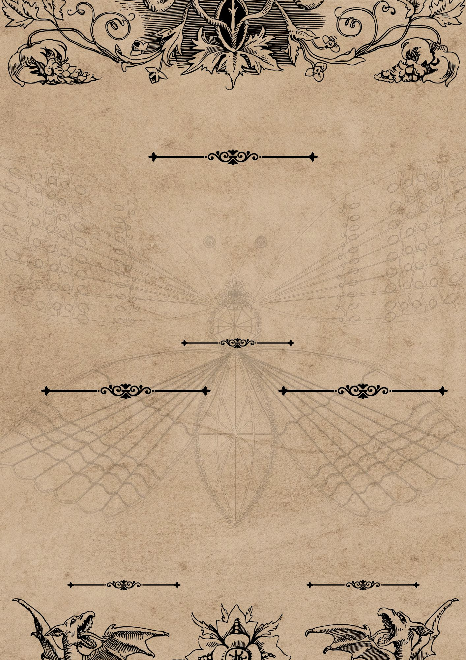
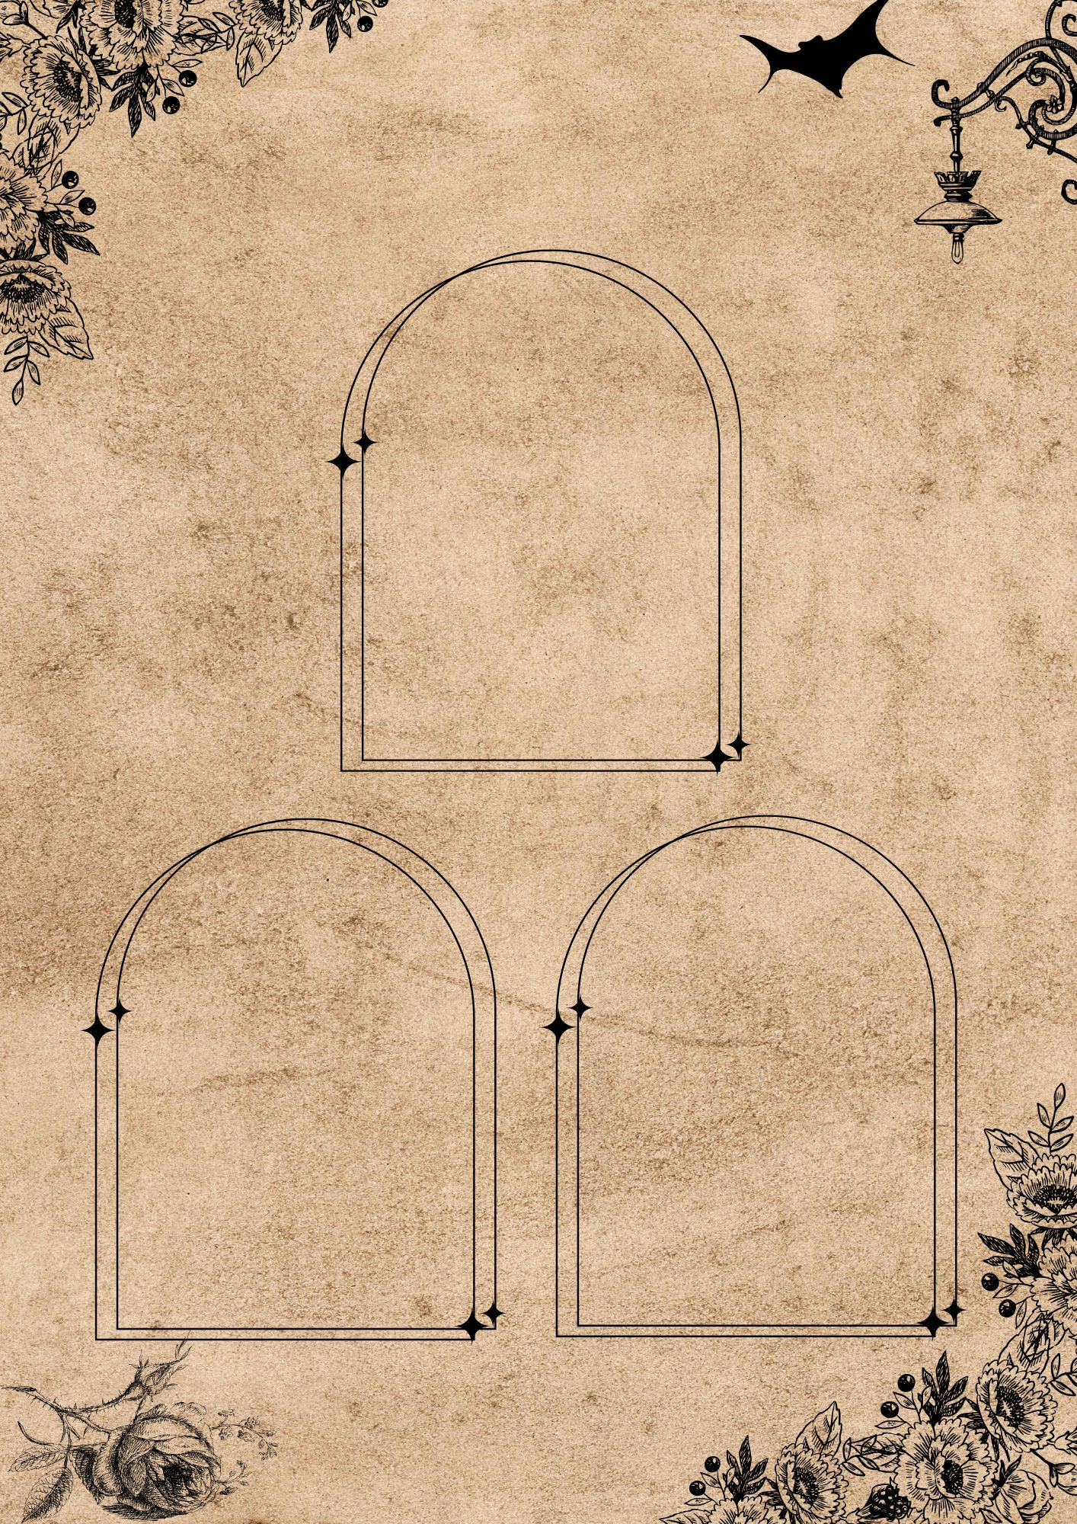
Little Reminders

My Mood

Secrets

Today’s Story

Things I Could Not Leave Behind
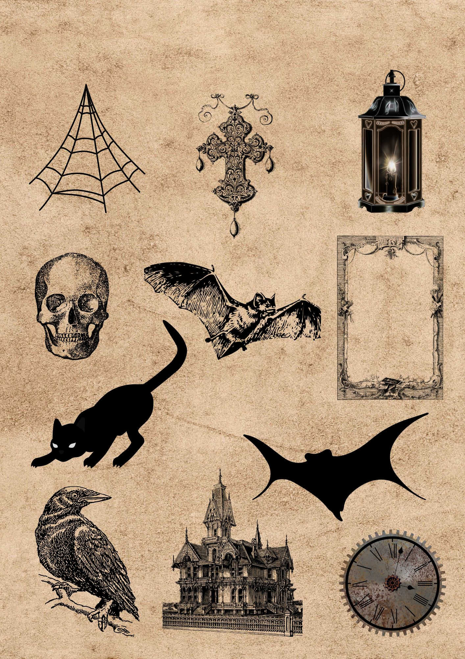
Cut & Paste in your journal

Gothic Fussy Cuts

