Herbs Planting Calendar
Variety | Indoor Date | Outdoor Date | Days to Maturity | Planting Depth | Soil | Light | Soil Temperature (℉) | Height (inches) | Spread (inches) | Growth Type
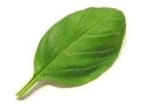  Basil | Anytime | March-August | 70 | 1/2 inch | Rich and moist | Full | 70 | 12-24 | 12 | Annual
Catnip | Start 4-8 weeks before the last frost | April-June | 75 | 1/4 inch | Rich | Full | 70 | 12-36 | 18 | Perennial
Chives | Anytime | April-May | 80 | 3/8 inch | Rich and moist | Full | 65 | 12-18 | 18 | Perennial
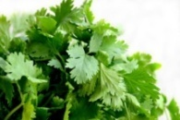  Coriander | Start 2 weeks before the last frost | March-August | 65 | 3/8 inch | Light | Partial | 60 | 12-36 | 4 | Annual
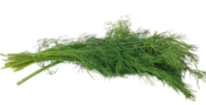  Dill | Start October-April | March-August | 60 | 3/8 inch | Rich | Full | 65 | 36-48 | 12 | Annual
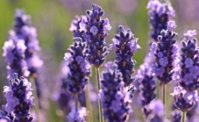  Lavender | Anytime | April-May or October | 2 years | 1/2 inch | Well drained | Full | 70 | 18-36 | 24 | Perennial
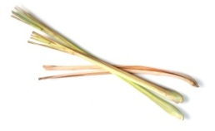  Lemongrass | Start February-March | March-August | 75 | 3/8 inch | Rich | Partial | 70 | 12-24 | 18 | Annual
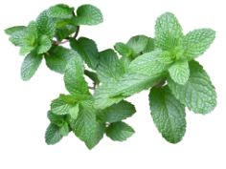  Mint | Anytime | April-May | N/A | 1/8 inch | Rich and moist | Partial | 70 | 12-24 | 18 | Perennial
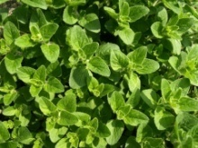  Oregano | Anytime | April-May | 85 | 1/4 inch | Poor | Full | 70 | 12-24 | 18 | Perennial
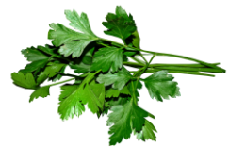  Parsley | Anytime | March-August | 80 | 3/8 inch | Rich | Partial | 70 | 18-24 | 6-8 | Biennial
Rosemary | Anytime | April-May | 85 | 1/8 inch | Less acidic | Full | 70 | 48-72 | 48 | Perennial
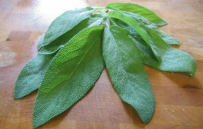  Sage | Anytime | April-May | 70 | 1/8 inch | Well drained | Full | 60 | 12-48 | 30 | Perennial
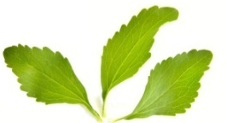  Stevia | Start February-March | April-May | 100 | 1/8 inch | Rich | Full | 65 | 18-30 | 20 | Perennial
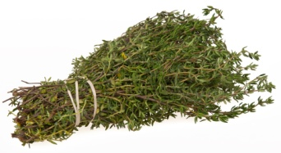  Thyme | Anytime | April-May | 80 | 1/4 inch | Fertile | Partial | 70 | 6-24 | 10 | Perennial

