Perennial Flowers Planting Calendar
Variety | Indoor Sowing Date | Outdoor Sowing Date | Height (inches) | Spread (inches) | Soil | Light | Planting Depth | Soil Temperature (℉)
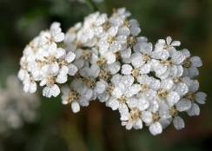  Achillea | 6-8 | Early | 24-36 | 18 | Average, well-drained | Full | 1/8 inch | 60
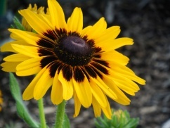  Black Eyed Susan | N/A | Anytime | 24-36 | 18 | Average | Full | 1/4 inch | 60
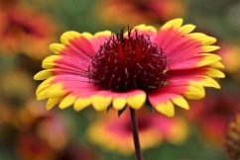  Blanket Flower | 6 | 1-4 after | 24-40 | 14-16 | Loose | Full | 1/8 inch | 70
1.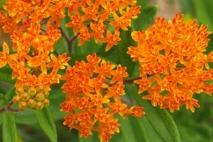  Butterfly Flower | 6-8 | 1-4 after | 24-36 | 18-20 | Sandy, well-drained | Partial | 1/8 inch | 70
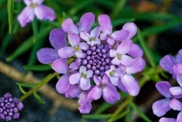  Candytuft | 6-8 | Early | 1-15 | 8-10 | Well-drained | Partial | 1/8 inch | 65
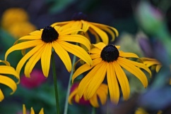  Coneflower | N/A | Early | 24-42 | 12-18 | Well-drained | Full | 1/4 inch | 70
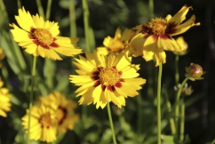  Coreopsis | N/A | 1-4 after | 18-48 | 6 | Moist | Full/Partial | 1/8 inch | 70
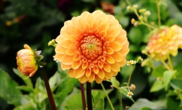  Dahlia | 6-8 | Early | 12-36 | 16-24 | Rich, fertile | Full | 1/8 inch | 65
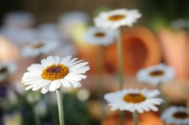  Daisies | N/A | Early | 12-36 | 8-20 | Rich, well-drained | Full | 1/8 inch | 60
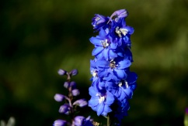  Delphinium | 6 | 1-4 after | 12-48 | 18 | Average | Full/Partial | 1/8 inch | 60
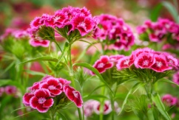  Dianthus | 6-8 | Early | 18-24 | 10-12 | Rich, well-drained | Full | 1/8 inch | 70
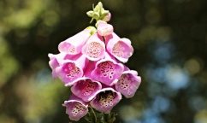  Foxglove | N/A | Early | 24-60 | 24 | Average | Full/Partial | 1/8 inch | 65
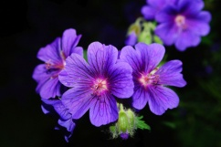  Geraniums | 6-10 | 1-4 after | 6-36 | 6-20 | Any soil | Full/Partial | 1/8 inch | 70
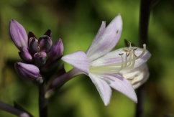  Hosta | 6-10 | Early | 24-40 | 24-40 | Well-drained | Partial | 1/2 inch | 70
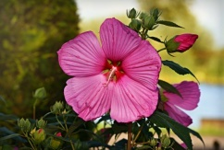  Hollyhock | 6-8 | Early | 48-72 | 18-24 | Rich, well-drained | Full/Partial | 1/8 inch | 65
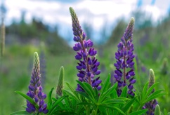  Lupine | N/A | 2-4 after | 24-36 | 12-14 | Average | Full/Partial | 1/8 inch | 70
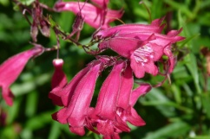  Penstemon | 6-8 | 2-6 | 12-36 | 18 | Loose | Full | Top | 70
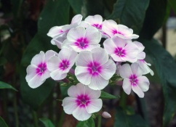  Phlox | 6-8 | Early | 6-18 | 8-10 | Rich, loose | Full | 1/8 inch | 60
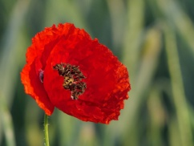  Poppy | 6-8 | Anytime | 24-30 | 8-18 | Any soil | Full/Partial | 3/8 inch | 60
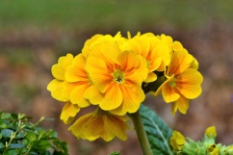  Primrose | N/A | Early | 8-15 | 12-18 | Rich, moist | Full/Partial | 1/8 inch | 60
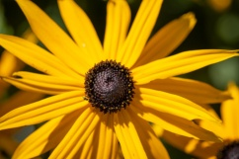  Rudbeckia | N/A | Anytime | 24-36 | 12-24 | Average | Full | 1/4 inch | 60
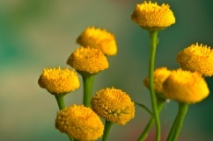  Tansy | N/A | Early | 36-48 | 6 | Average | Full/Partial | 1/4 inch | 65
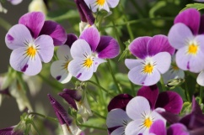  Viola | 6-8 | Early | 4-8 | 6 | Average | Partial | 1/8 inch | 65

