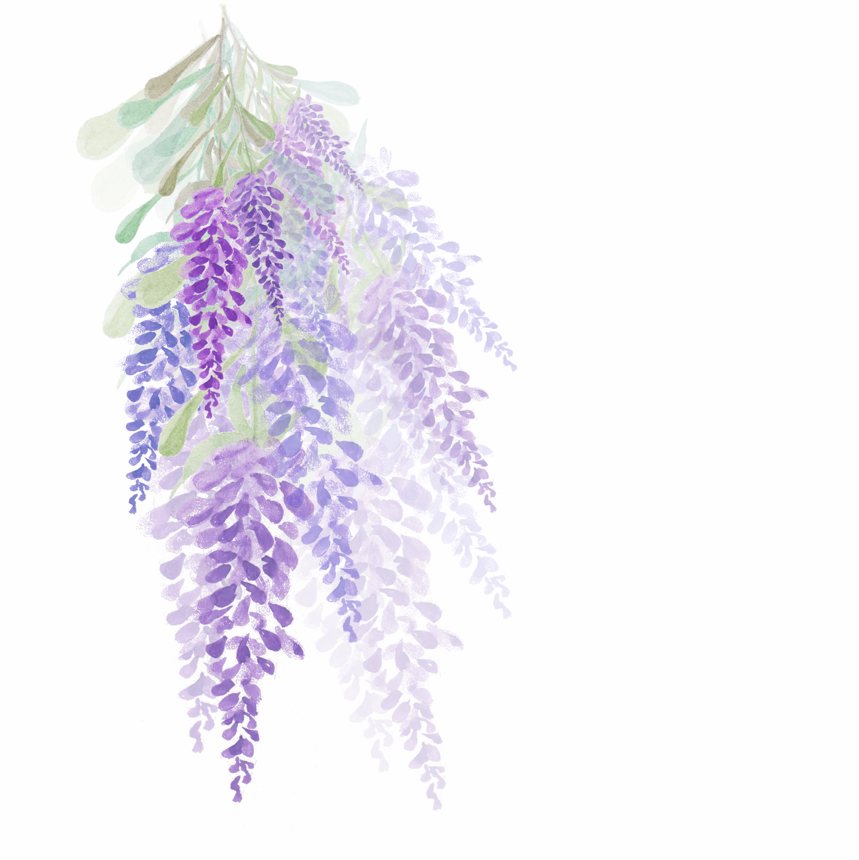

TODAY’S PLAN

**PRIORITES**

|  |
| --- |
|  |
|  |
|  |
|  |
|  |
|  |
|  |
|  |
|  |

**TODAY’S SCHEDULE**

|  |  |
| --- | --- |
|  |  |
|  |  |
|  |  |
|  |  |
|  |  |
|  |  |
|  |  |
|  |  |
|  |  |
|  |  |
|  |  |
|  |  |
|  |  |
|  |  |
|  |  |
|  |  |
|  |  |
|  |  |
|  |  |
|  |  |
|  |  |
|  |  |
|  |  |
|  |  |
|  |  |
|  |  |
|  |  |
|  |  |



|  |
| --- |
| **WATER** |
| **BREAKFAST** |
| **LUNCH** |
| **DINNER** |
| **WORKOUT** |

**DAILY CHECKLIST**

|  |
| --- |
|  |
|  |
|  |
|  |
|  |
|  |
|  |

**NOTES**