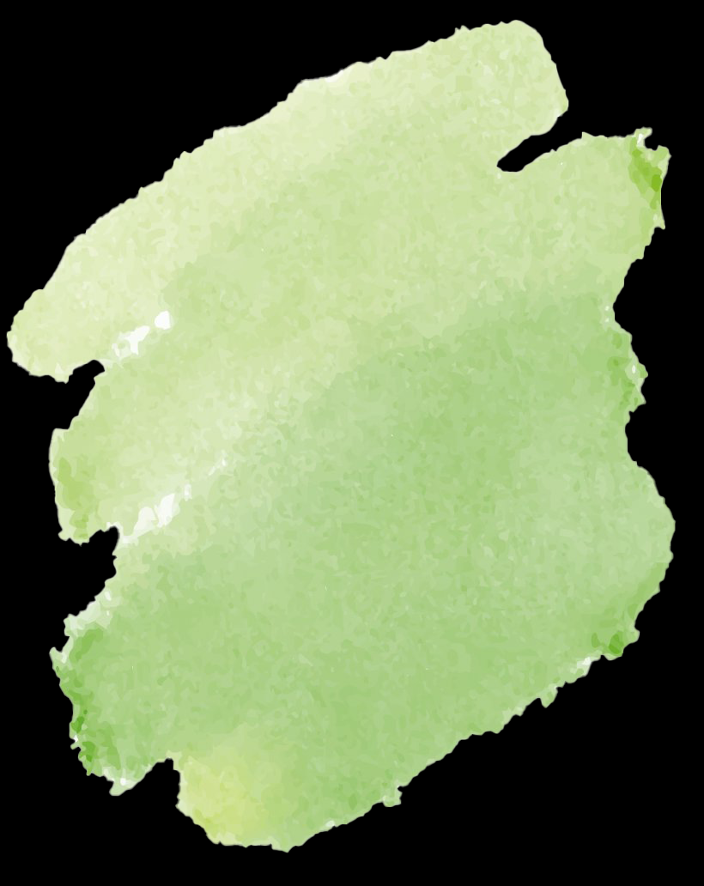
Seed Starting Log
Crop/  Seed | Date  Planted | Date Germinated | Date Transplanted | Additional  Notes

