Vegetable Planting Calendar
Variety | Sowing Date | Days to Maturity | Family of Four (typical growing season) | Days to Germination | Planting Depth | Plants (inches) | Seeds per 100 foot row | Soil Temperature (F)
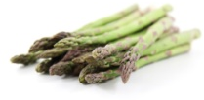  Asparagus | January-February | 720+ | 40 plants | 10 | 4 | 14 | 1 oz. | 75
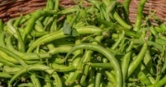  Bean Bush | May-June | 50+ | 25 foot row | 7 | 1.5 | 18 | .5 lb. | 80
Bean Vine | May-June | 70+ | 25 foot row | 7 | 1.5 | 4 | .5 lb. | 80
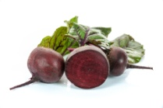  Beets | March-July | 40+ | 15 foot row | 4 | 0.5 | 4 | 1 oz. | 85
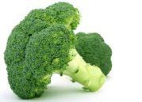  Broccoli | April-June | 70+ | 15 foot row | 4 | 1 | 24 | .25 oz. | 80
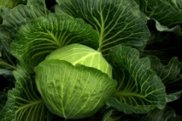  Cabbage | April-May | 100+ | 15 plants | 4 | 0.5 | 24 | .25 oz. | 85
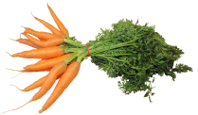  Carrots | January-August | 65+ | 30 foot row | 6 | 0.5 | 3 | .5 oz. | 80
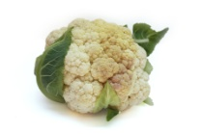  Cauliflower | January-June | 60+ | 15 plants | 5 | 0.5 | 15 | .25 oz. | 80
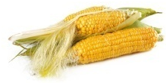  Corn | April-May | 60+ | 75 plants | 5 | 1 | 3 | .4 lb. | 95
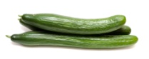  Cucumbers | April-July | 50+ | 6 plants | 3 | 1 | 36 | .5 oz. | 95
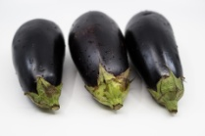  Eggplants | April-June | 80+ | 6 plants | 6 | 0.5 | 24 | 50 plants | 85
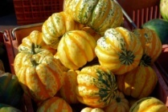  Gourds | April-May | 100+ | varies | 10 | 0.5 | 48 | .25 oz. | 80
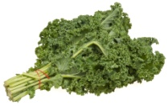  Kale | May-July | 55+ | 20 foot row | 4 | 0.25 | 18 | .25 oz. | 80
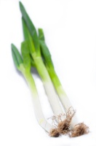  Leeks | March-May | 120+ | 10 foot row | 7 | 0.25 | 6 | .5 oz. | 80
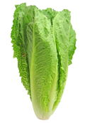  Lettuce | February-October | 55+ | 15 foot row | 3 | 0.25 | 10 | .25 oz. | 75
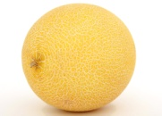  Melon | March-April | 85+ | varies | 4 | 1 | 36 | .5 oz. | 80
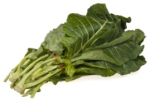  Mustard Greens | April-September | 35+ | 10 foot row | 8 | 0.25 | 6 | .25 oz. | 75
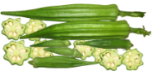  Okra | April-September | 55+ | 15 foot row | 6 | 1.5 | 18 | 2 oz. | 95
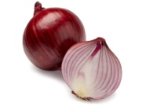  Onions | February-April | 90+ | 40 foot row | 6 | 0.5 | 3 | 1 oz. | 75
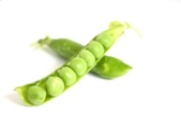  Peas | March-June | 60+ | 40 foot row | 6 | 1.5 | 5 | 1 lb. | 75
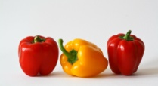  Peppers | January-May | 75+ | 10 plants | 8 | 0.5 | 24 | 50 plants | 85
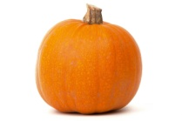  Pumpkins | April-June | 90+ | 3 plants | 4 | 3 | 6 | .5 oz. | 90
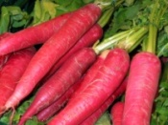  Radishes | March-August | 30+ | 4 foot row | 4 | 0.5 | 2 | 1 oz. | 85
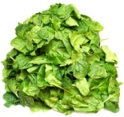  Spinach | March-July | 45+ | 20 foot row | 5 | 0.5 | 6 | 1 oz. | 70
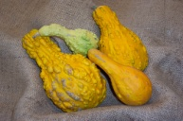  Squash | March-April | 65+ | 3 plants | 4 | 1 | 36 | .75 oz. | 95
Strawberries | December-February | 120+ | 2 plants | 10 | 0.125 | 18 | 1 gram | 80
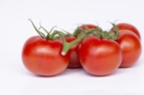  Tomatoes | January-May | 70+ | 15 plants | 6 | 0.5 | 32 | 50 plants | 85
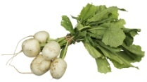  Turnips | March-August | 45+ | 15 foot row | 3 | 1.5 | 3 | .5 oz. | 85
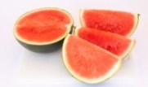  Watermelon | March-April | 110+ | 6 plants | 4 | 1 | 72 | .75 oz. | 95

