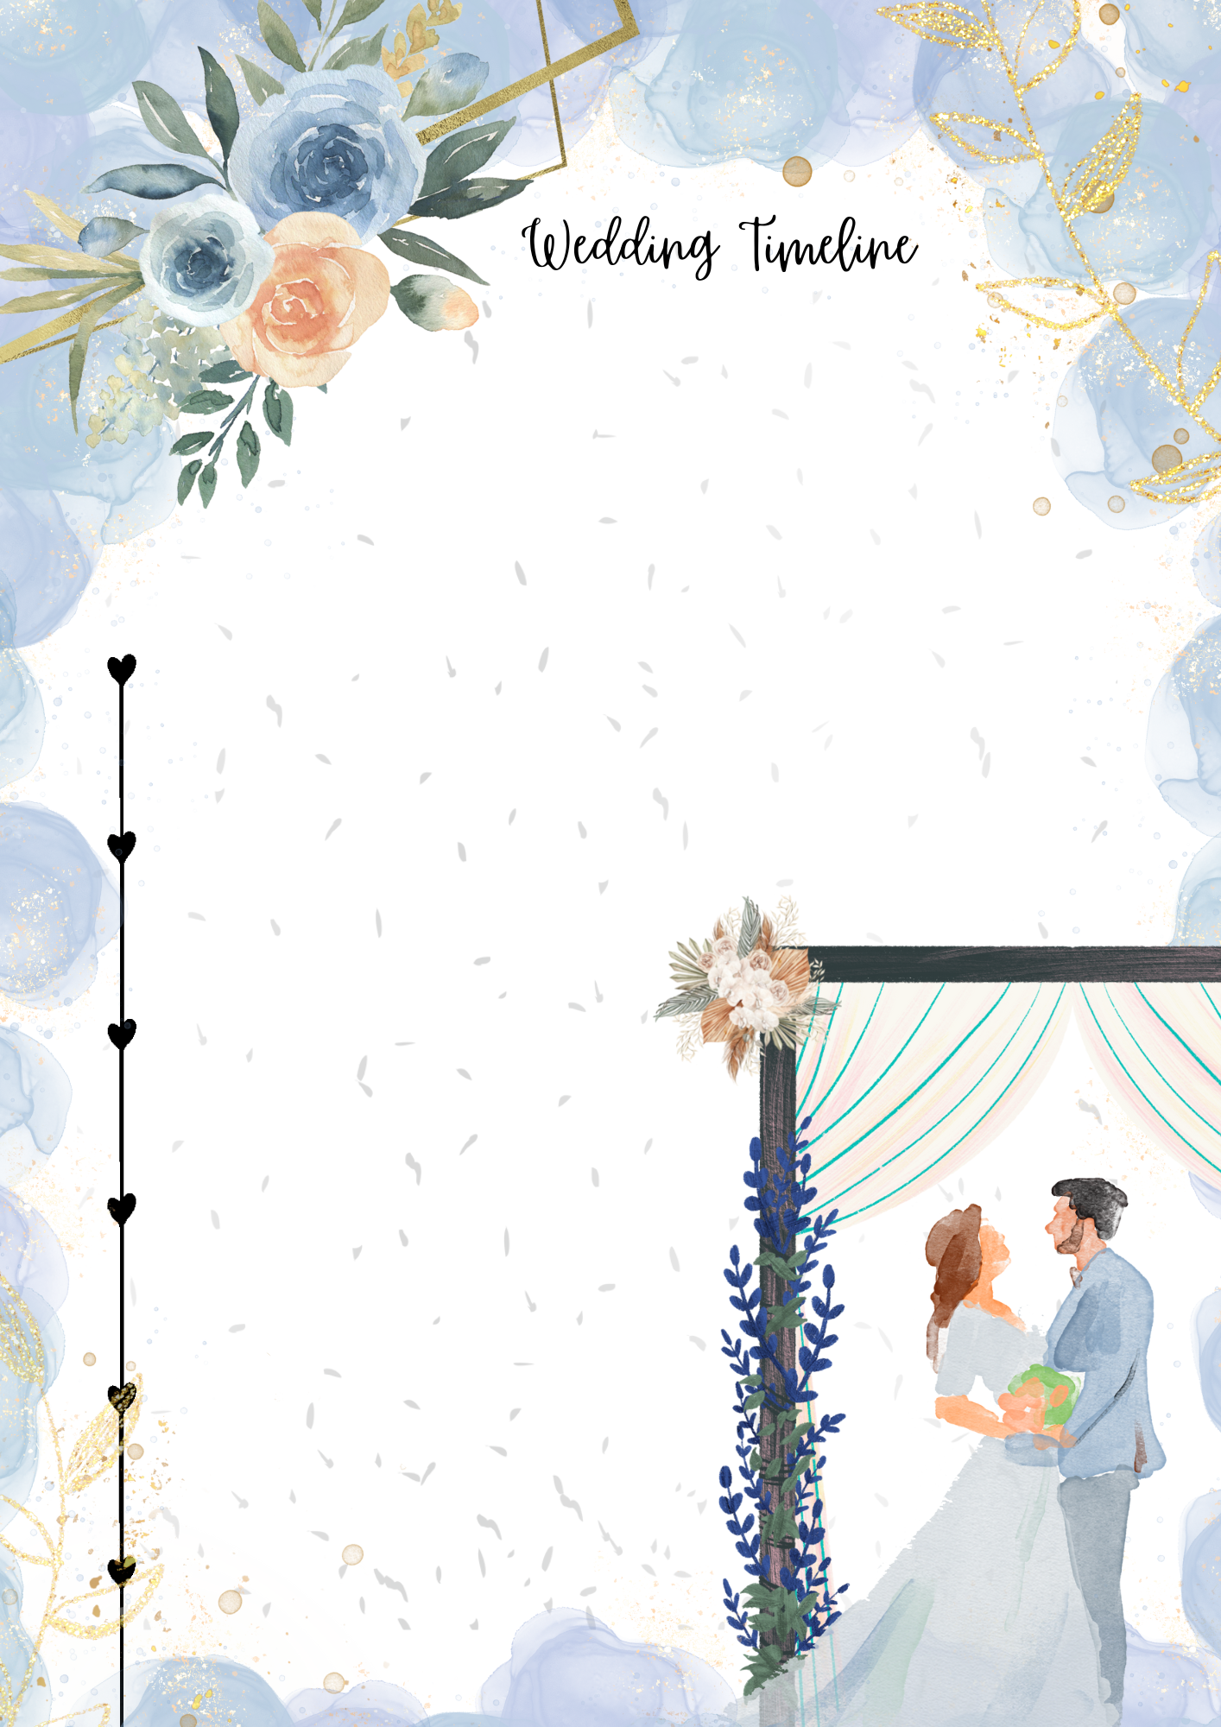

6:00 PM Opening

6:30 PM Cocktails

6:45 PM Arrival of Bride & Groom

7:30 PM Reception

8:00 PM Bouquet and Garter Toss

9:00 PM Last Dance

Ana & Smith’s

Wedding Day

[Templates ©calendarlabs.com](https://www.calendarlabs.com/calendar-templates/)